**APU UNIVERSITY** | **LECTURER: Mr. Usman Hashmi**

**TP066168**

**INTAKE: APD1F2109CS(CYB)**

**Python Bank Mangment System**

**MODULE:** **CT108-3-1-PYP-L-6 (Degree)**

**individual assignment**

**MOHAMED KHAIRY MOHAMED ABDELRAOUF**



**PYTHON PROGRAMING**

2021

Table of Contents

2 Introduction 3

3 MAIN MENU: 4

4 OPEN ACCOUNT MENU: 7

5 ISLAMIC OPEN ACCOUNT: 10

6 SAVING OPEN ACCOUNT: 13

7 CURRENT OPEN ACCOUNT: 16

8 LOGIN: 19

9 SPUER USER MENU: 22

10 ADD ADMIN: 25

11 ADD ISLAMIC CUSTOMER ACCOUNT: 28

12 ADD SAVING ACCOUNT: 31

13 ADD CURRENT CUSTOMER ACCOUNT: 34

14 DISPLAY ALL USERS: 37

15 DISPLAY ALL PENDING: 39

16 GENERATE ID: 41

17 ADMIN MENU: 44

18 CURRNCY CONVERTER CALCULATOUR: 47

19 CUREENT CUSTOMER MENU: 50

20 ISLAMIC CUSTOMER MENU: 53

21 DISPLAY DETAILS: 56

22 SAVING ACCOUNT MENU: 58

23 WITHDRRAW: 61

24 DEPOSIT: 64

25 CHANGE PASSWORD: 67

26 CHANGE USERNAME: 70

27 CURRENT LOAN MENU: 73

28 ISLAMIC LOAN MENU: 80

29 LOAN DEPOSIT: 85

30 LOAN DEPOSIT PAY: 88

31 PAY THE LOAN: 91

32 REPORT: 94

33 SHOW ALL TRANS: 96

34 Data Validation 97

35 These are some Samples of The Out put and input 99

36 Functions Table: 114

37 Conclusion: 117

38 References 118

**ASSUMPTION:**

1. **I assume** that the system is just thought about for the purchasers in Malaysia. Also, the purchasers will withdraw cash from anyplace.

2. **I assume** that the workers can contact the purchasers in two – three days of labor to open for the purchasers a brand-new account

3. **I assume** the purchasers will simply register for gap associate degree account on-line. But if the purchasers facing any problems they'll come back to the bank and there the workers will register for them

4. **I assume** that foreigners will open themselves associate degree account with no problems

5. **I assume** that customers and workers cannot amendment their user id, but they can amendment the countersign

6**. I assume** that workers will scrutinize customers distils for any weird

transactions

7. **I assume** that customers will look although their truncations to possess a glance

on what they're pocket money at

8. **I assume** that customers pay things on-line mistreatment the present account

9. **I assume** that customers WHO open bank account can withdraw cash once a year

10.**I assume** that workers account cannot deposit or withdraw cash and that they must open associate degree account within the bank to try and do That

# Introduction

A Bank could be a institution that accepts deposits, pays interest on pre-defined rates, clears checks, makes loans, and occasionally acts as associate degree interceder in financial deals. It jointly provides different financial services to its guests.

Bank operation governs multitudinous considerations related to bank so as to maximize gains. The considerations astronomically speaking embody liquidity operation, quality operation, liability operation and capital operation. we're going to bandy these areas in after chapters.

The main idea of the design is to develop online Banking system for banks. In present system all banking work is done manually. Customers must visit bank to Withdraw or Deposit quantum. In present bank system it's also delicate to find account information of account holder. In this bank operation system, we will automate all the banking process. In my bank operation system stoner can check his balance online and he can change his word. In this Software you can keep record for diurnal Banking deals. The main purpose of developing bank operation system is to design an operation, which could store bank data and give an interface for reacquiring client related details.

In This Project I’m going to Make 31 Functions and I’m going to dived it into 31 subheading every subheading I’m going to be divided into 3 Parts 2 Parts for Pseudo code, The Flow chart and The Last one is for the source code and the Explanation.

At the End I’m going to Put A screen Shots of The Output or The UI screen

I’ve Used:

Visual Basic Code for The Coding.

Draw io For the Flowchart.

Notepad++ For the pseudo code.

# MAIN MENU:

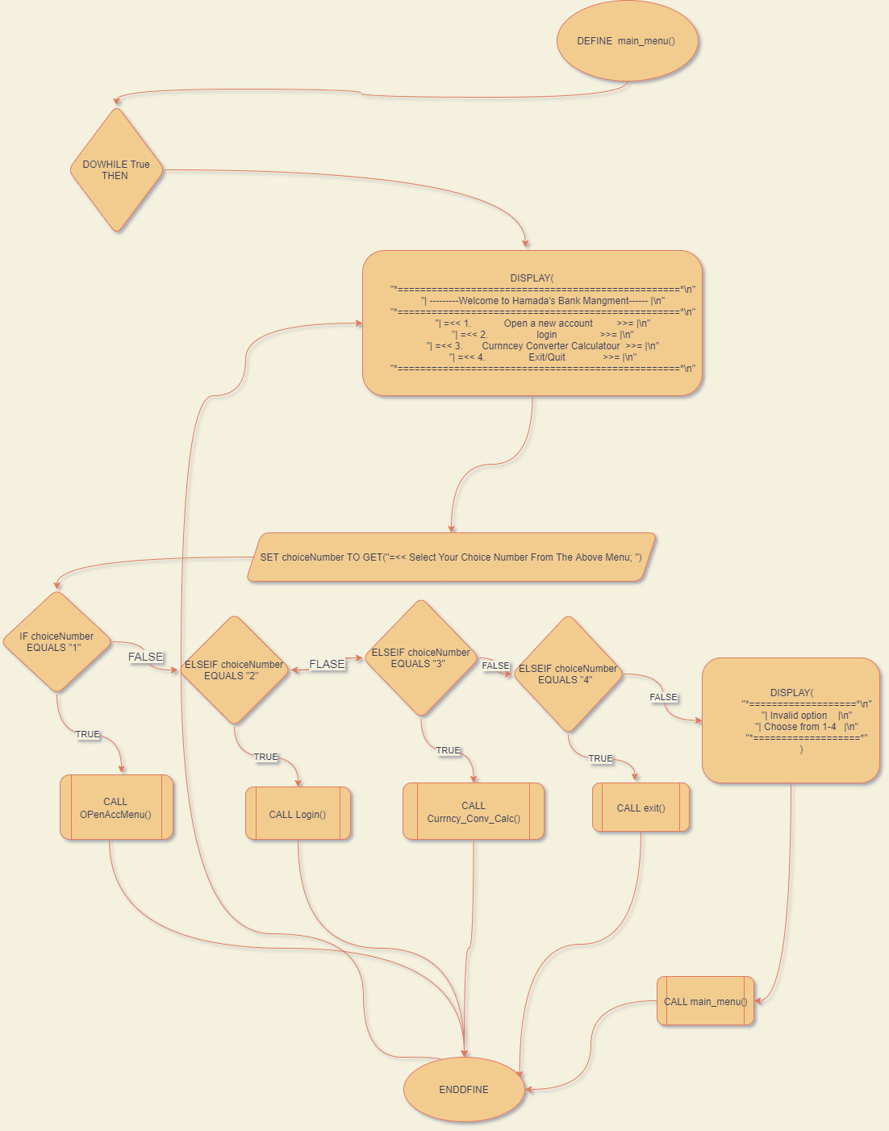**This The Flowchart of This Function:**

**This The Pseudo Code of This Function:**

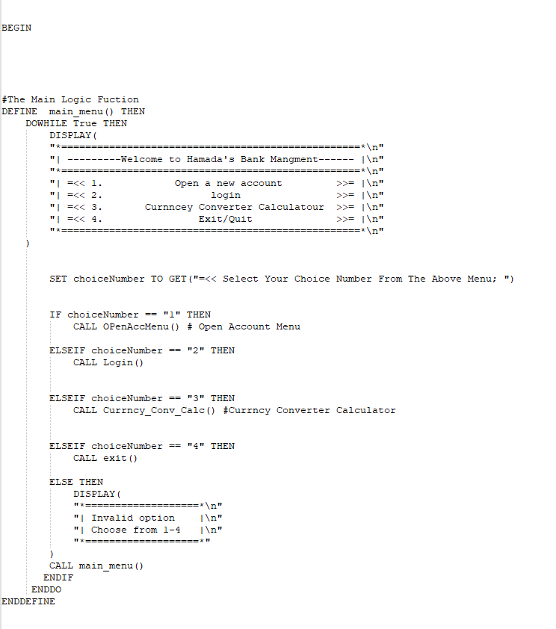

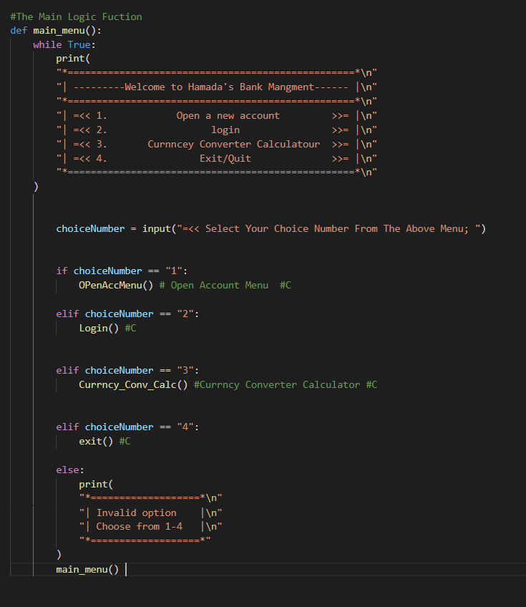**And This is The Source of This Function:**

# OPEN ACCOUNT MENU:

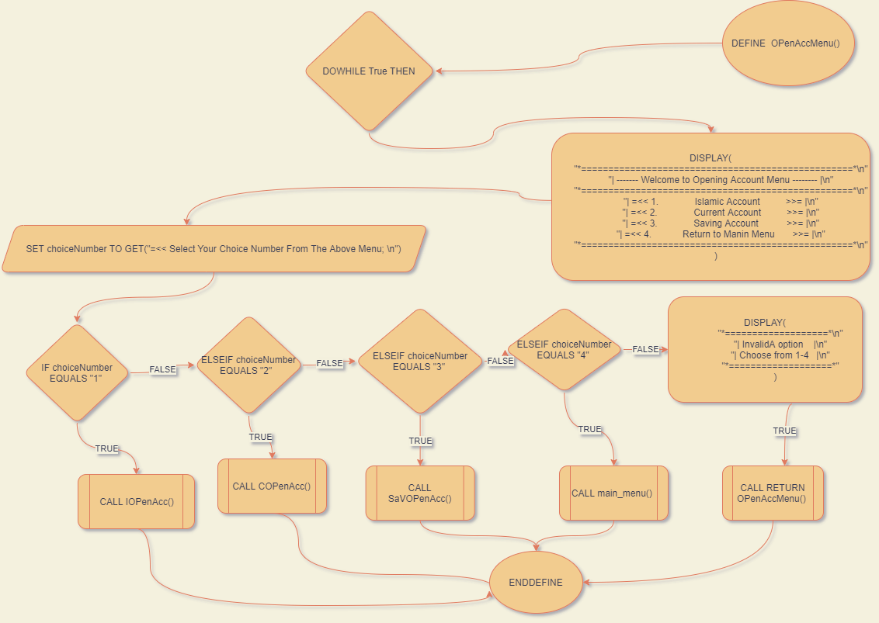**This The Flowchart of This Function:**

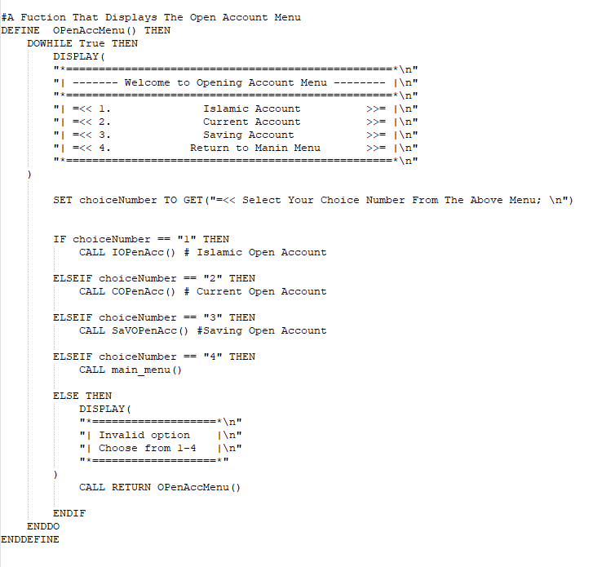**This The Pseudo Code of This Function:**

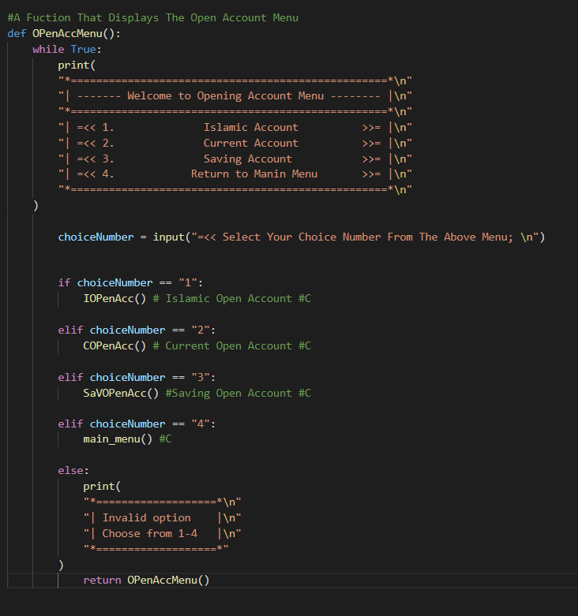**And This is The Source of This Function:**

# ISLAMIC OPEN ACCOUNT:

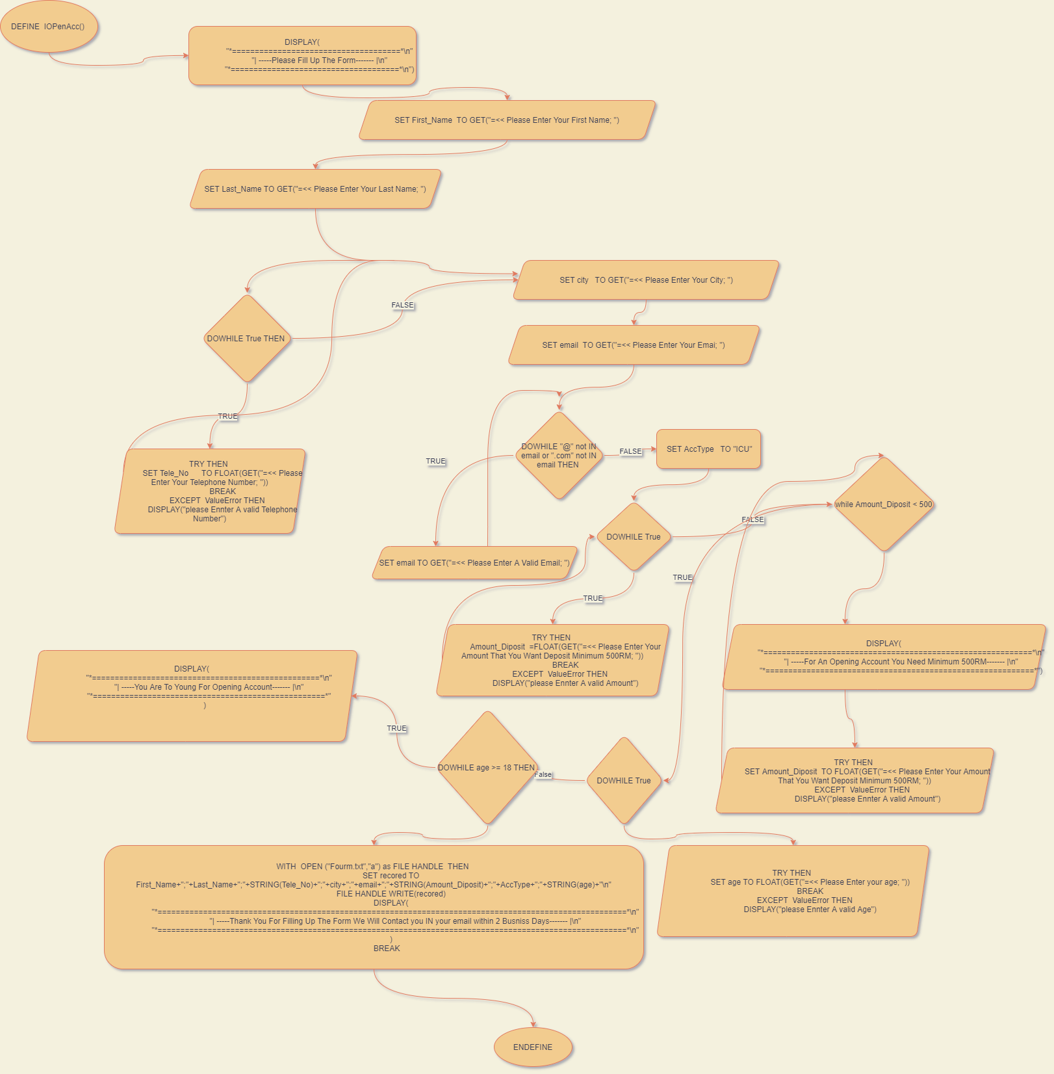**This The Flowchart of This Function:**

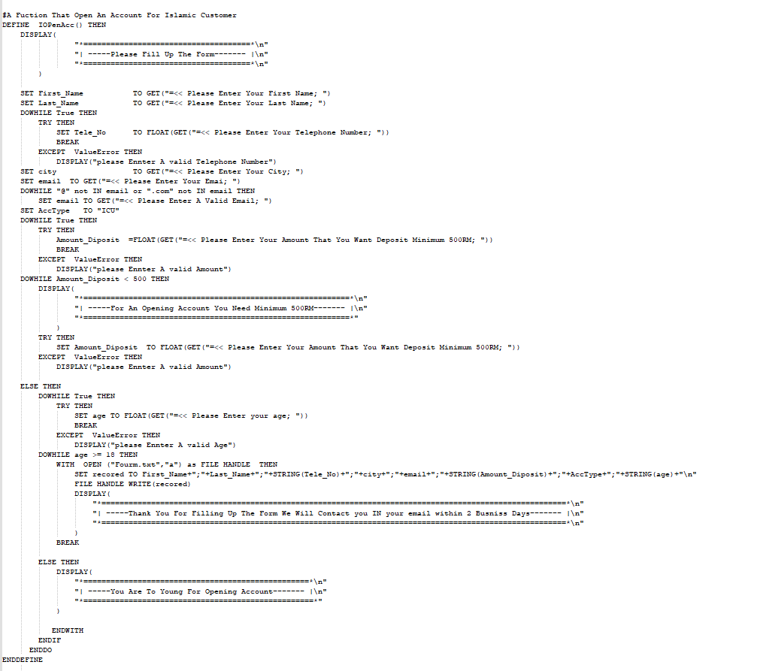**This The Pseudo Code of This Function:**

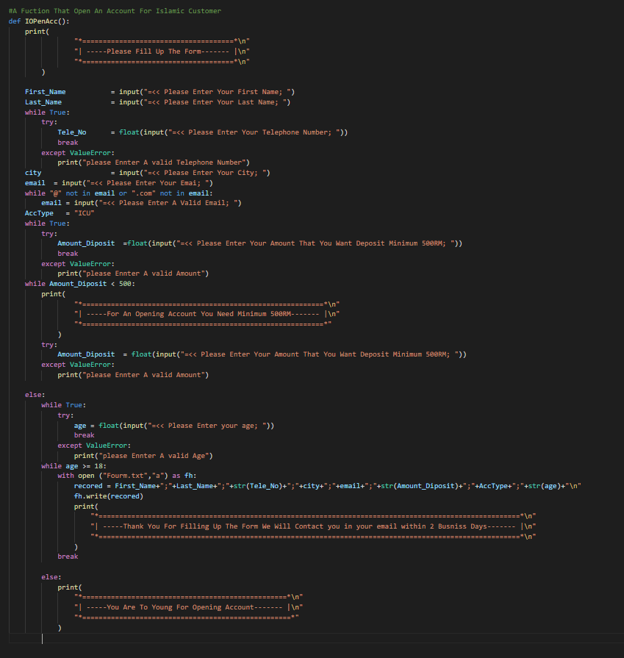**And This is The Source of This Function:**

# SAVING OPEN ACCOUNT:

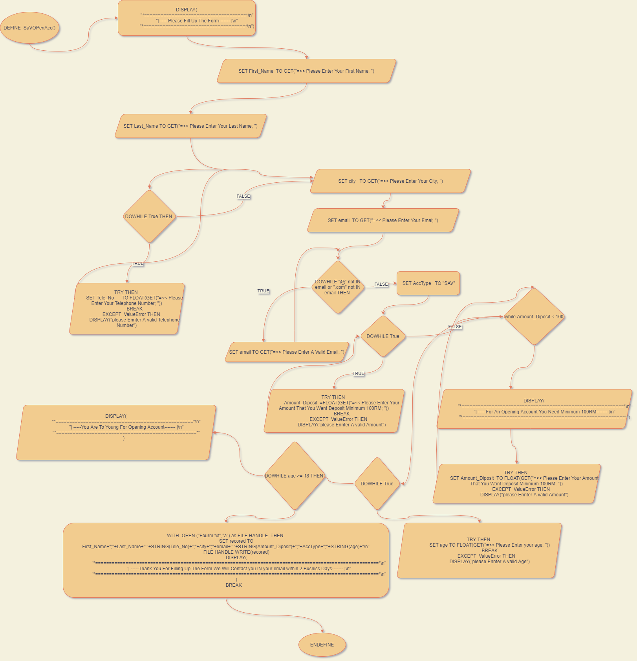**This The Flowchart of This Function:**

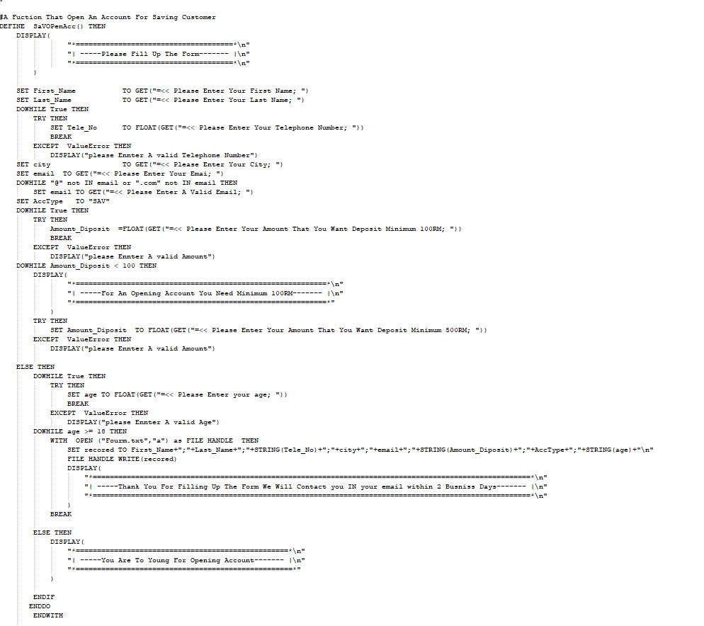**This The Pseudo Code of This Function:**

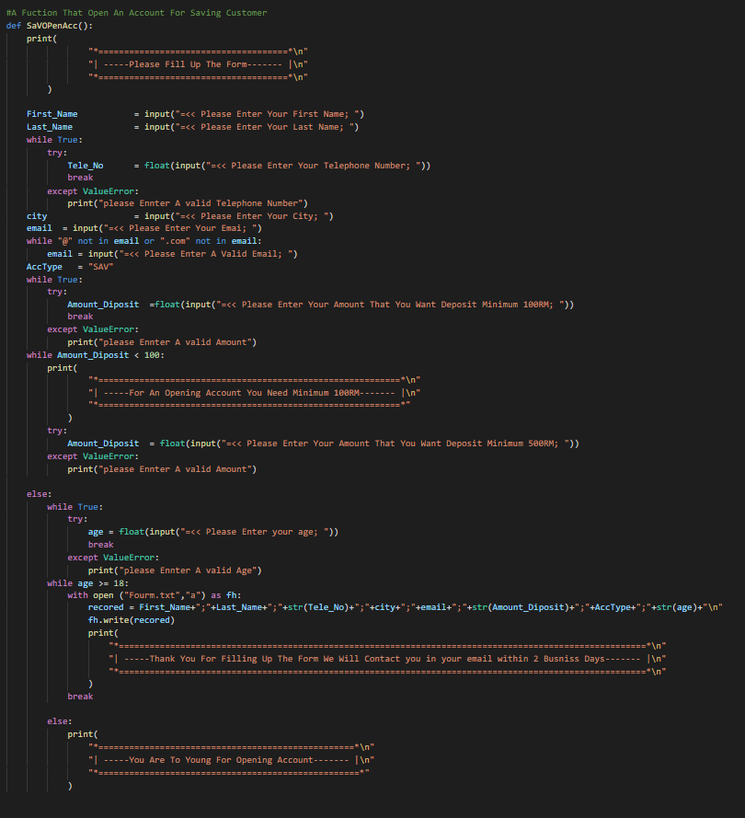**And This is The Source of This Function:**

# CURRENT OPEN ACCOUNT:

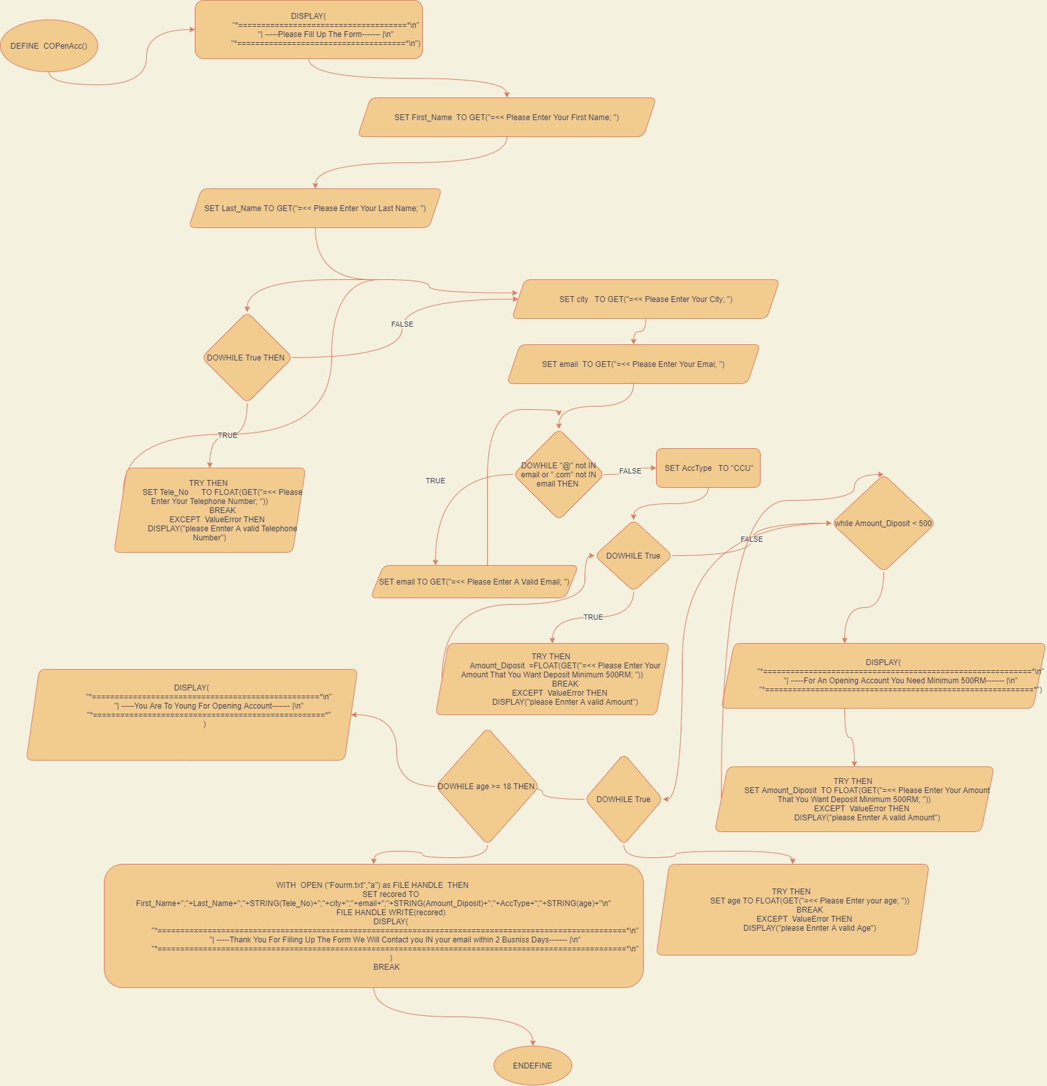**This The Flowchart of This Function:**

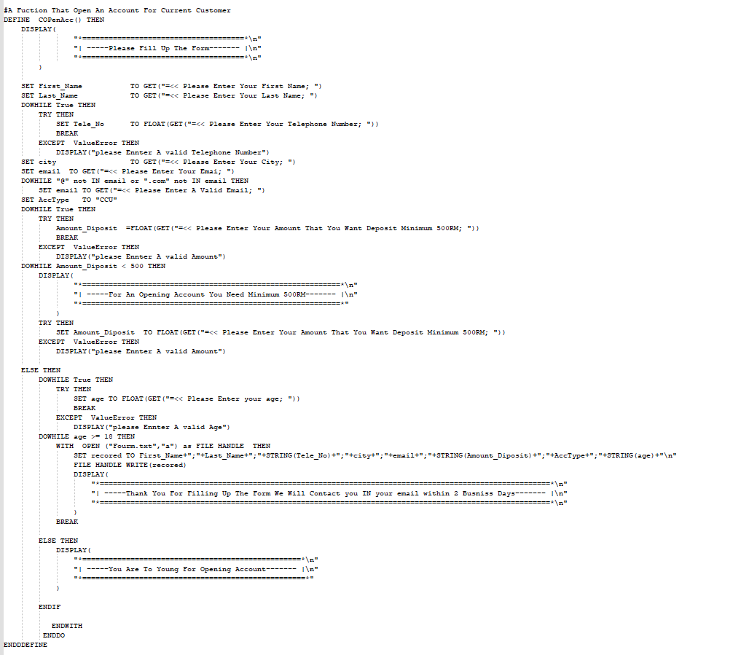**This The Pseudo Code of This Function:**

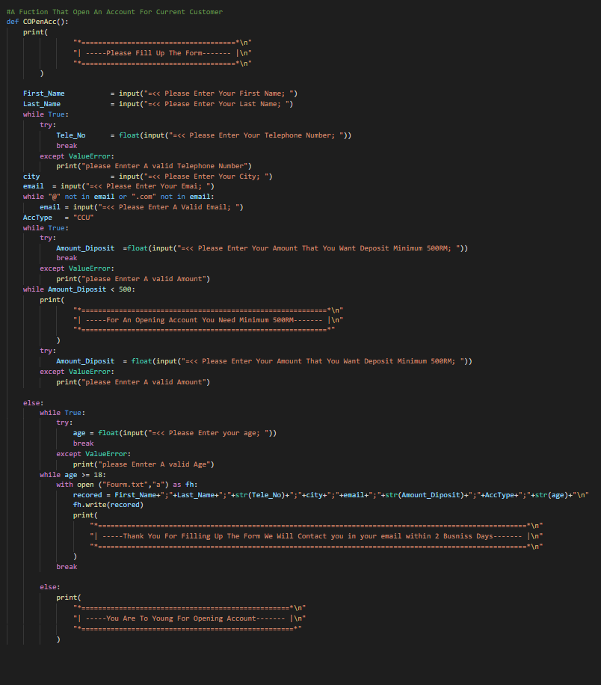**And This is The Source of This Function:**

# LOGIN:

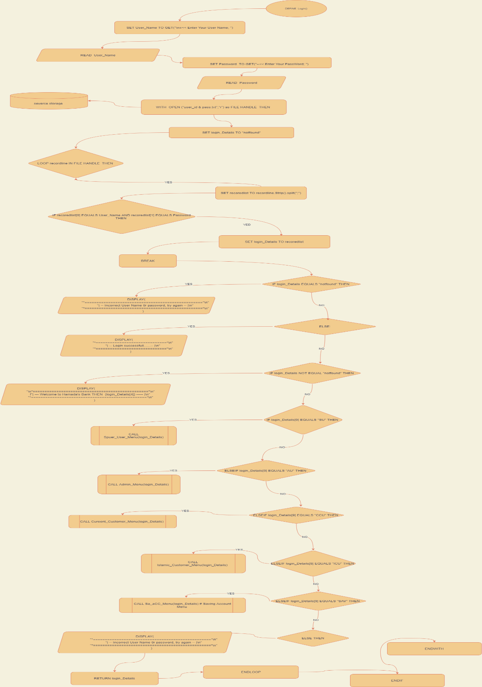**This The Flowchart of This Function:**

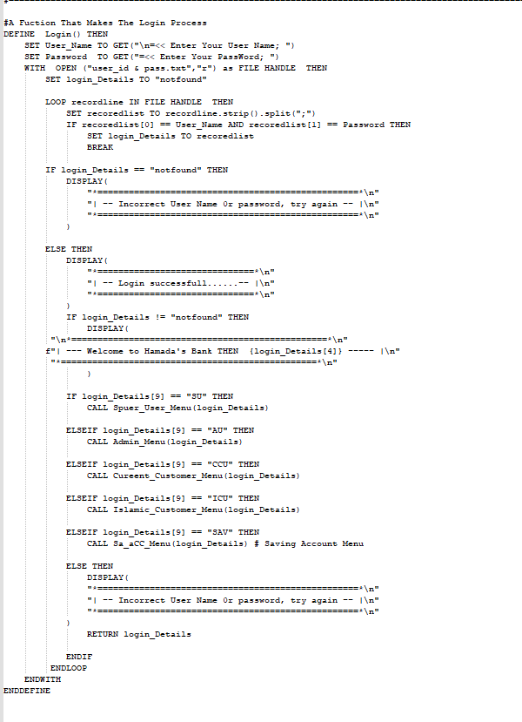**This The Pseudo Code of This Function:**

**And This is The Source of This Function:**

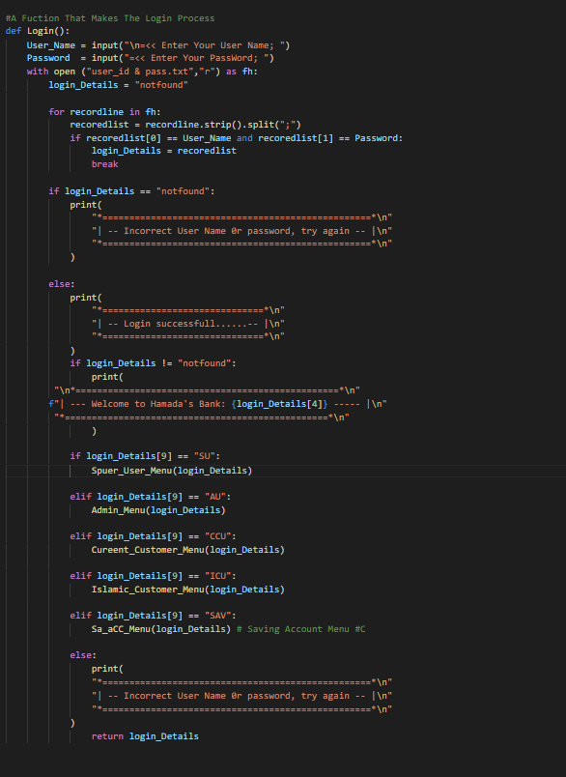

# SPUER USER MENU:

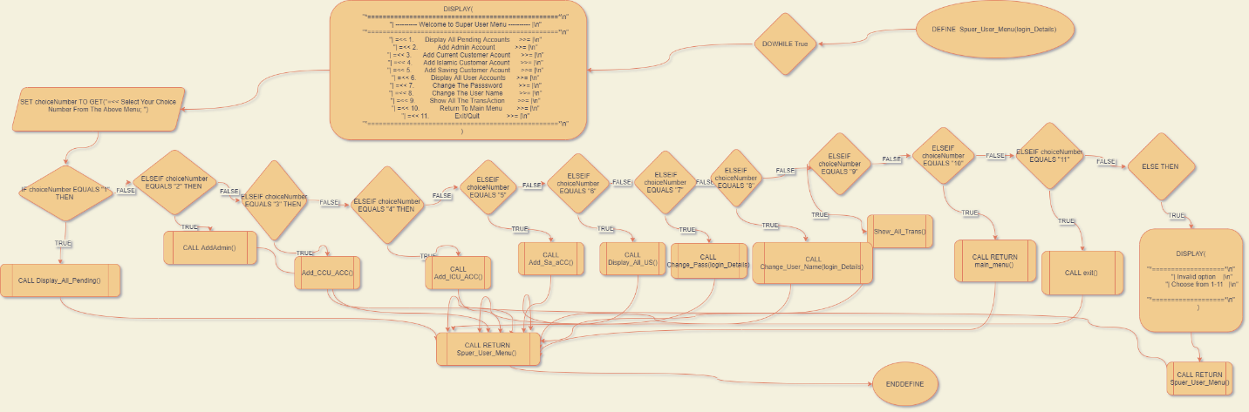**This The Flowchart of This Function:**

**This The Pseudo Code of This Function:**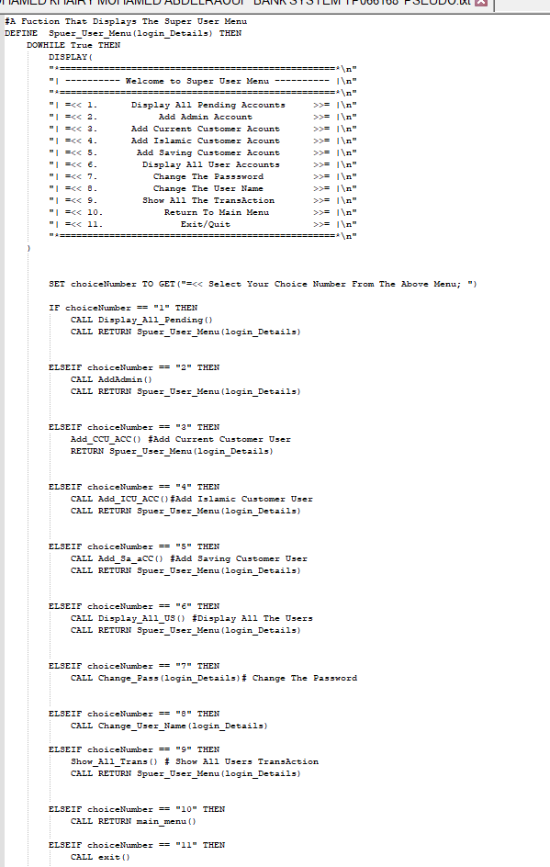

**And This is The Source of This Function:**

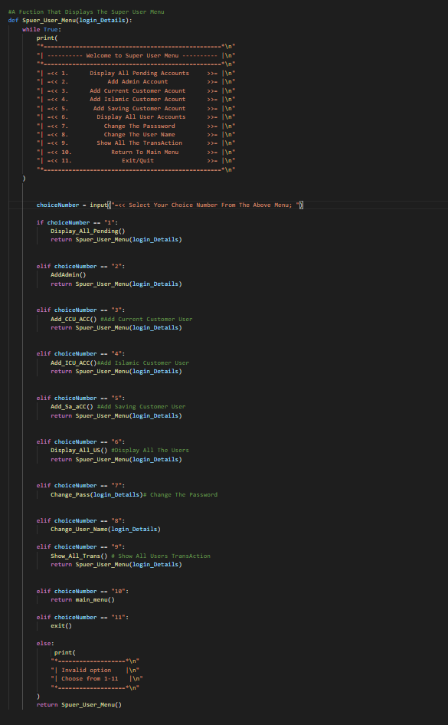

# ADD ADMIN:

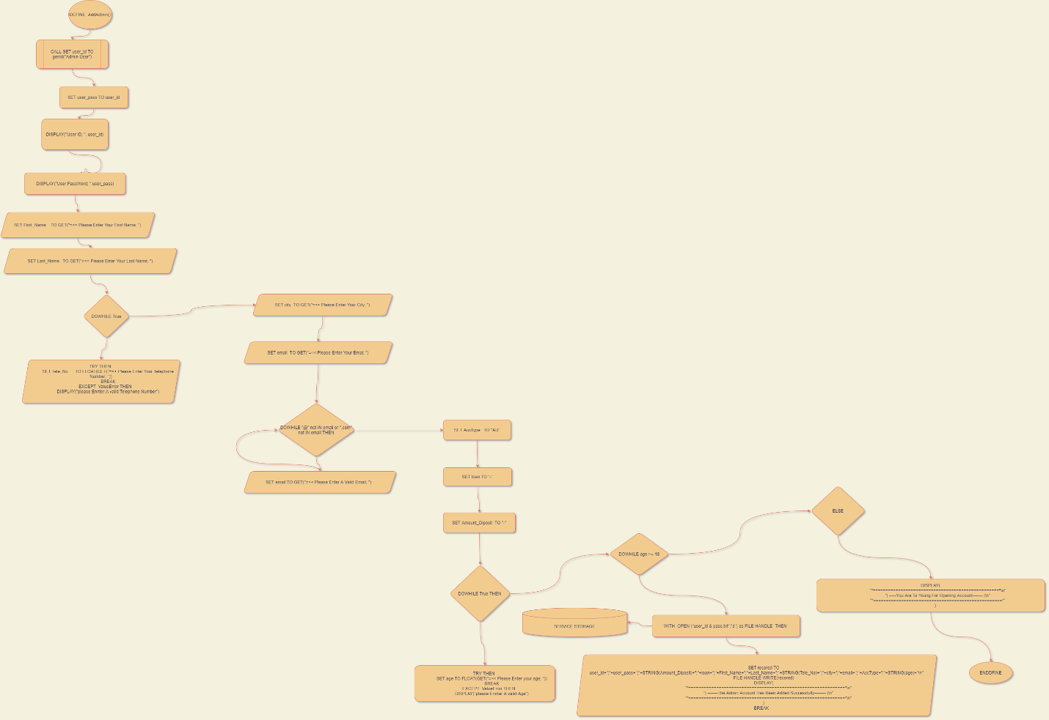**This The Flowchart of This Function:**

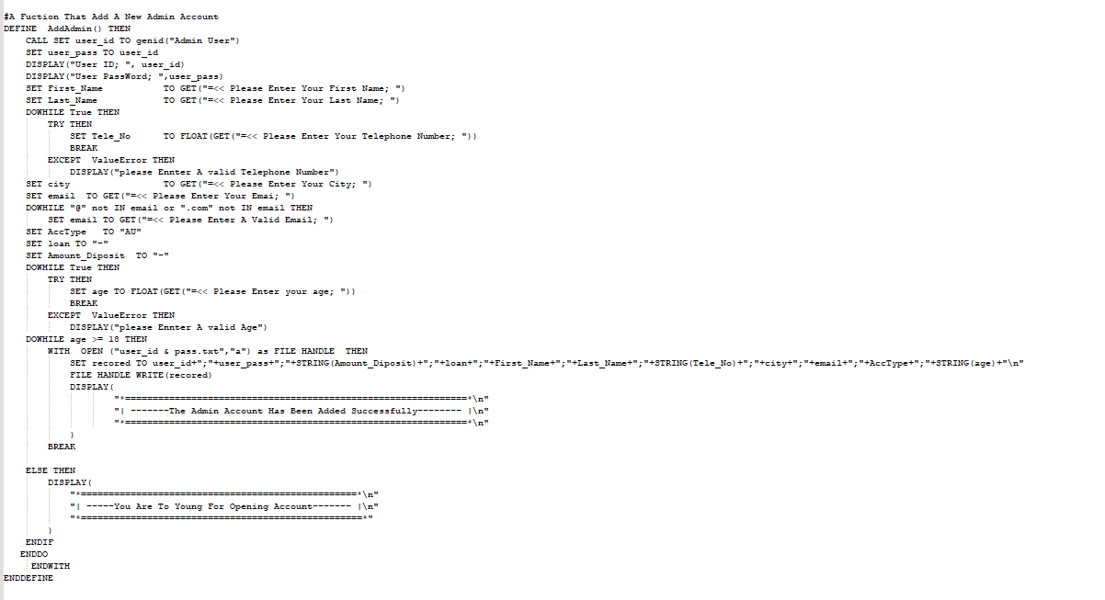**This The Pseudo Code of This Function:**

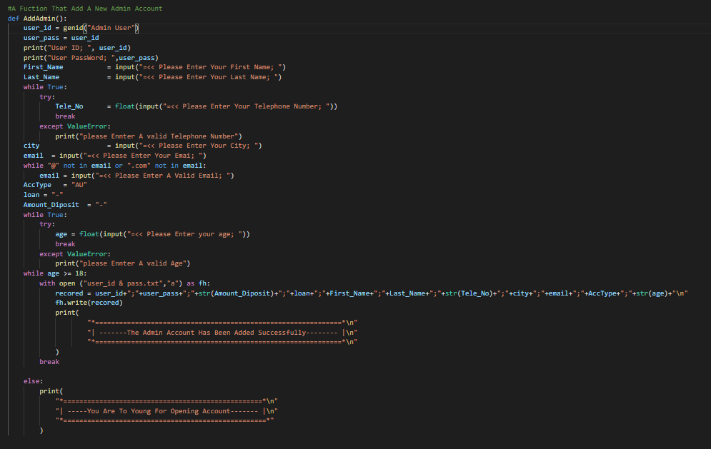**And This is The Source of This Function:**

# ADD ISLAMIC CUSTOMER ACCOUNT:

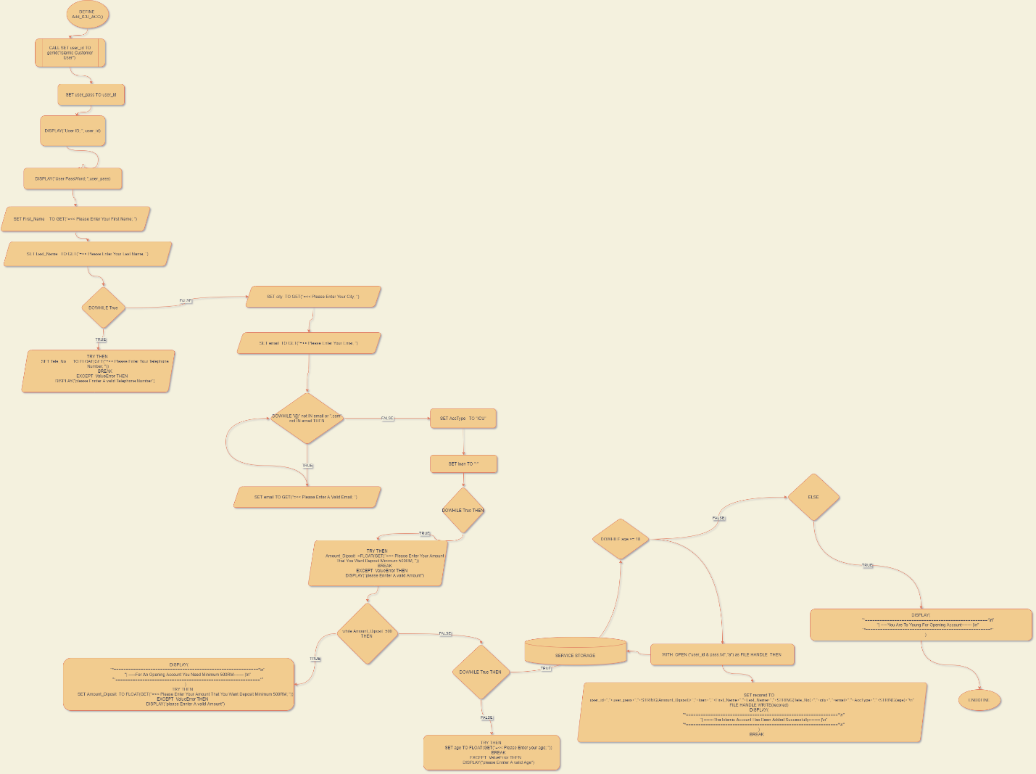**This The Flowchart of This Function:**

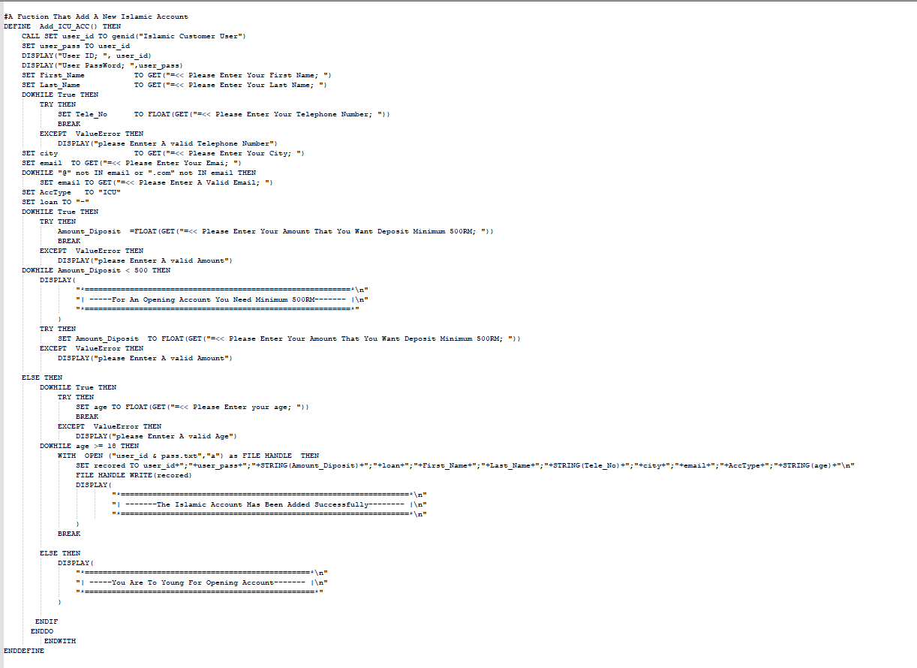**This The Pseudo Code of This Function:**

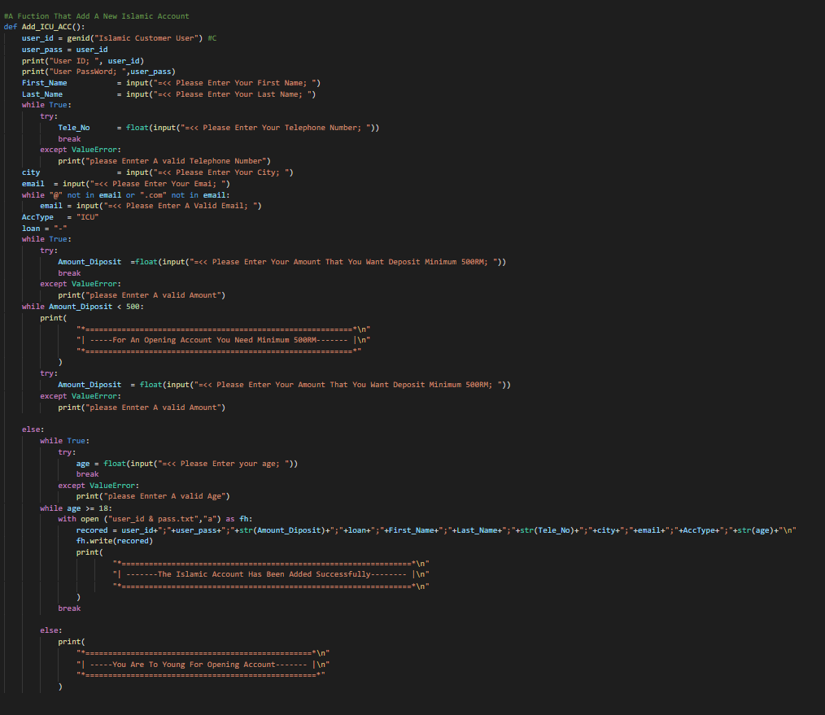**And This is The Source of This Function:**

# ADD SAVING ACCOUNT:

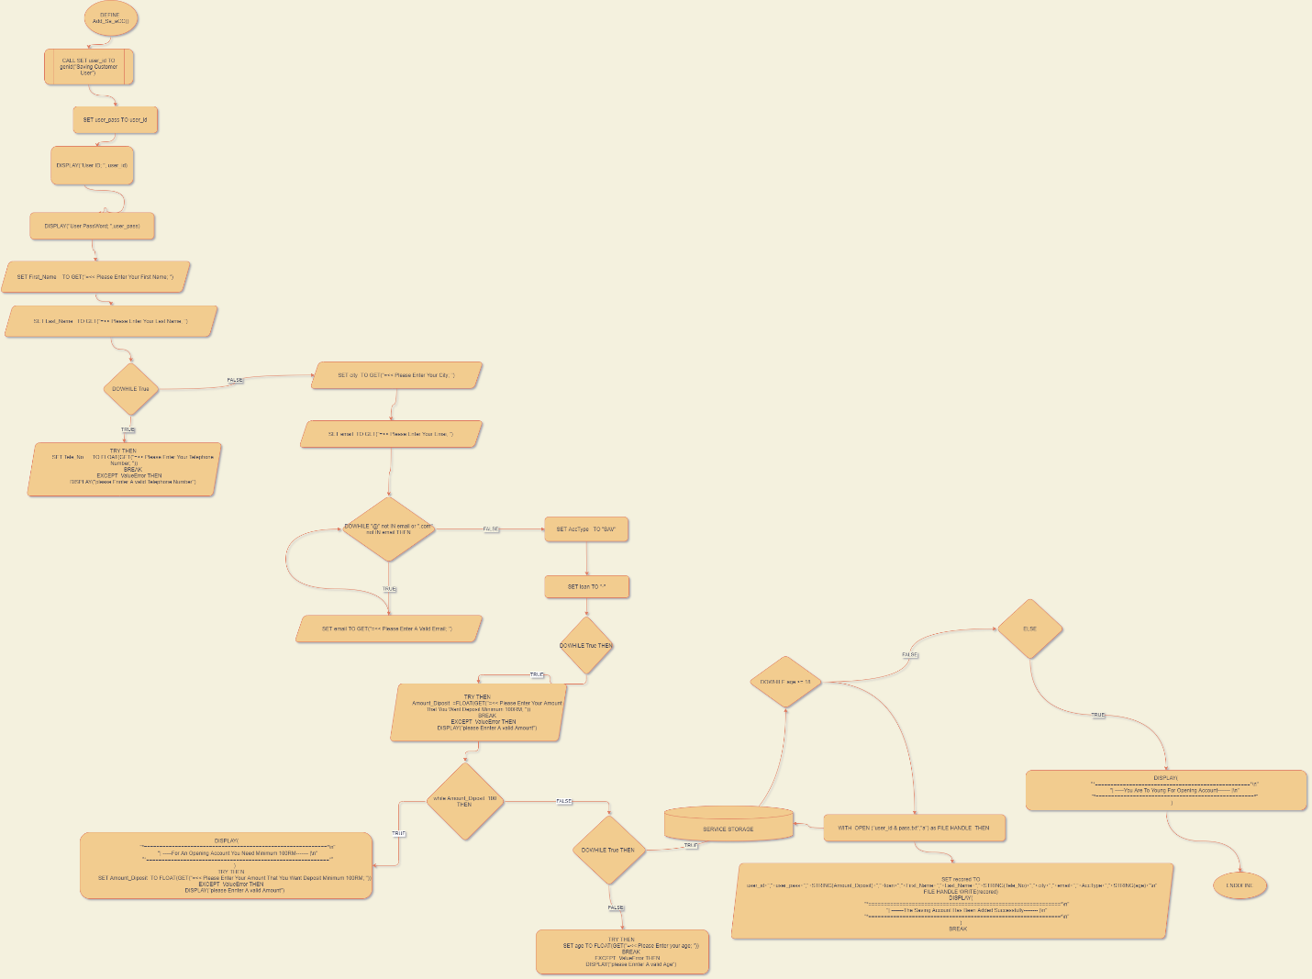**This The Flowchart of This Function:**

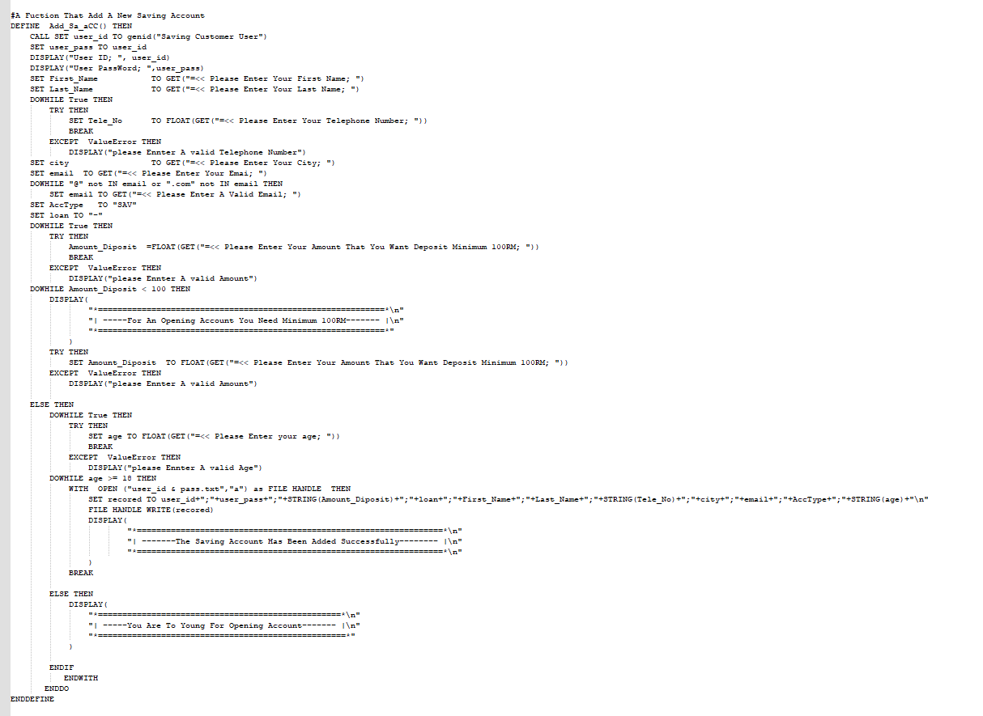**This The Pseudo Code of This Function:**

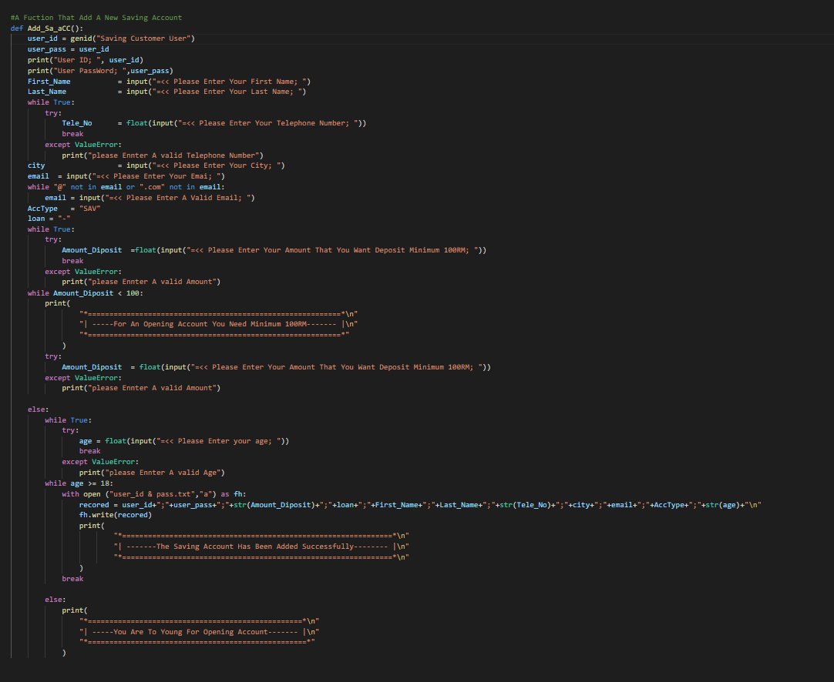**And This is The Source of This Function:**

# ADD CURRENT CUSTOMER ACCOUNT:

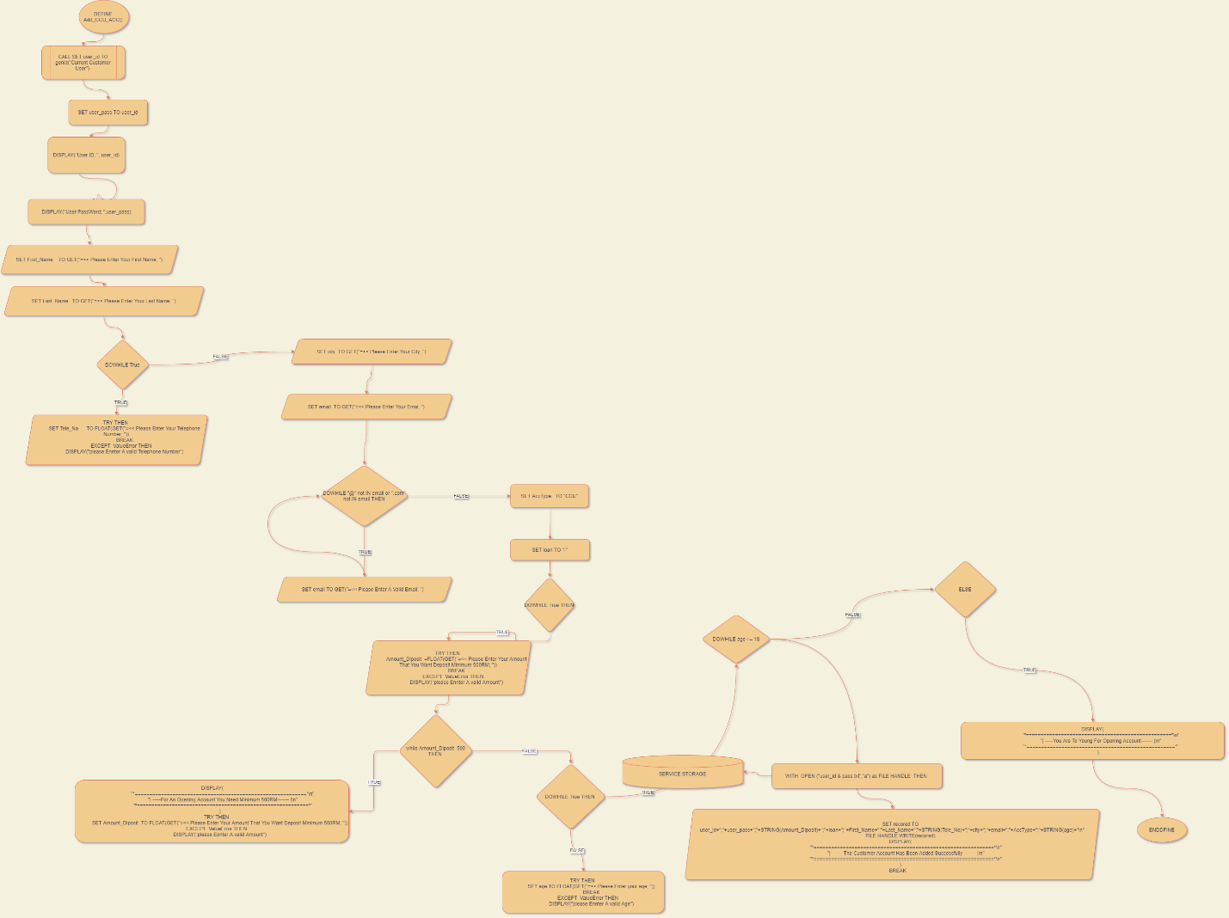**This The Flowchart of This Function:**

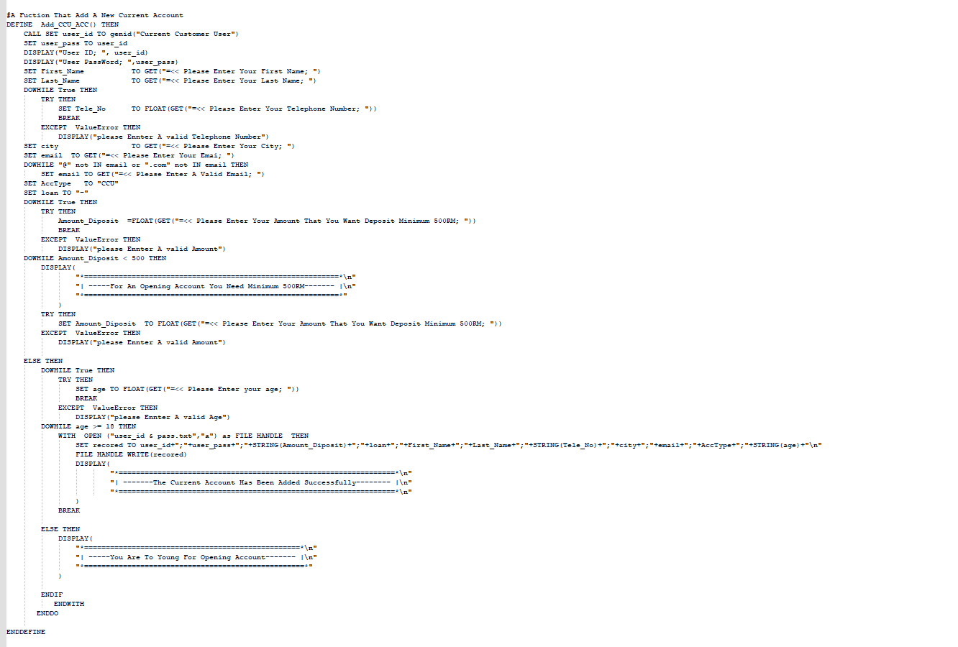**This The Pseudo Code of This Function:**

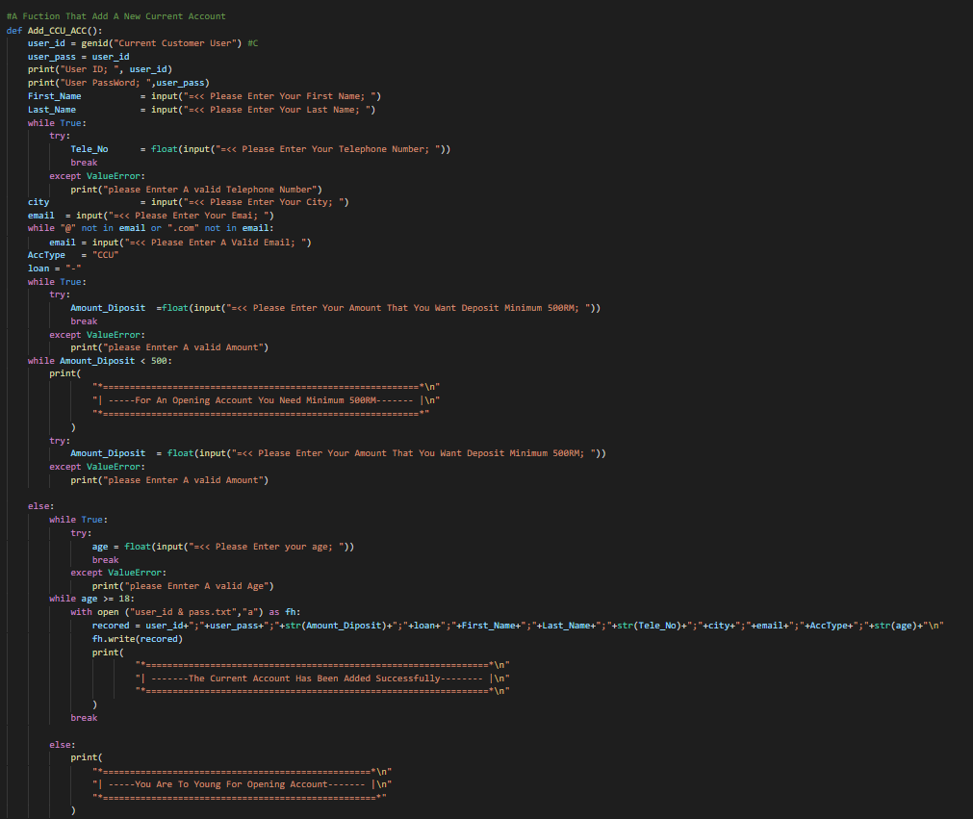**And This is The Source of This Function:**

# DISPLAY ALL USERS:

**This The Flowchart of This Function:**

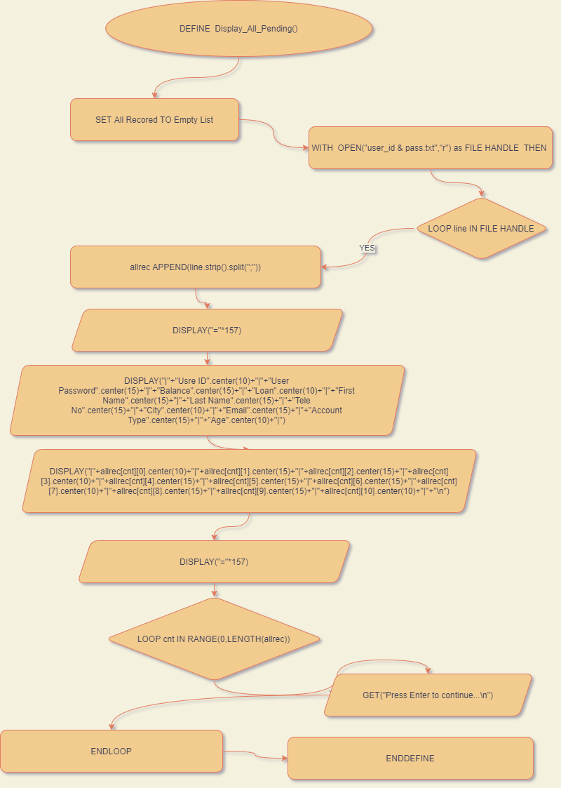

**This The Pseudo Code of This Function:**

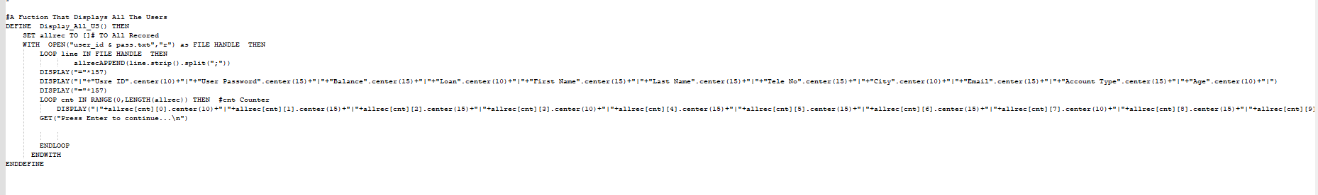

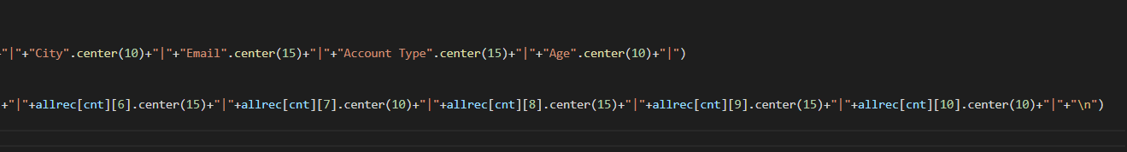**And This is The Source of This Function:**

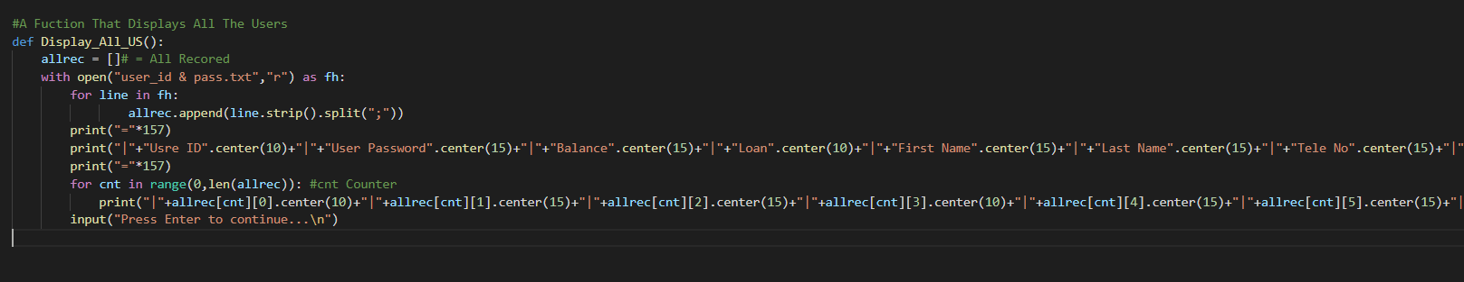

# DISPLAY ALL PENDING:

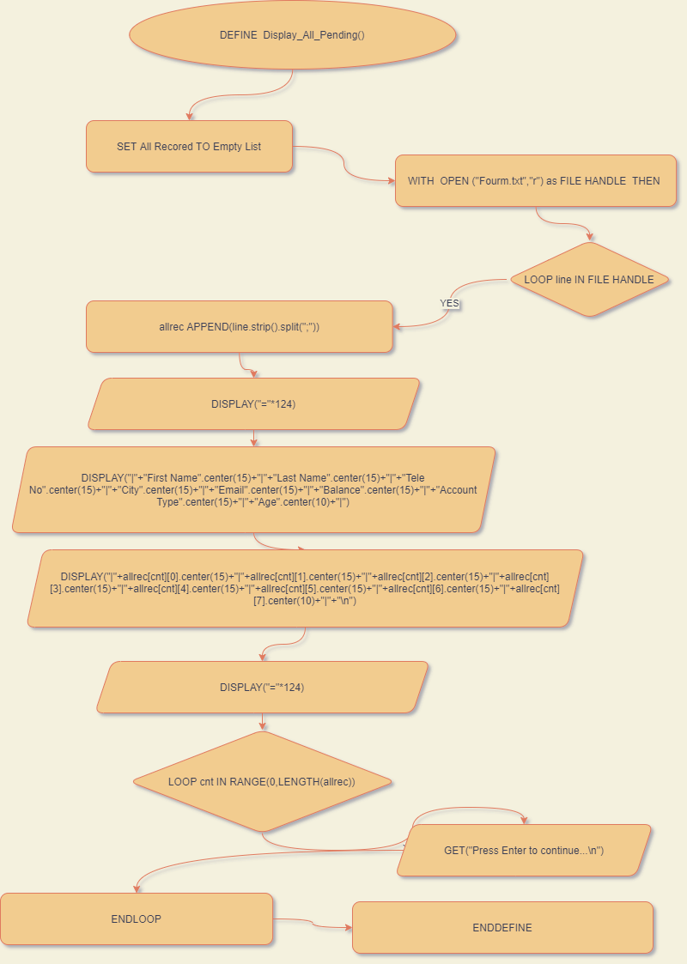**This The Flowchart of This Function:**

**This The Pseudo Code of This Function:**

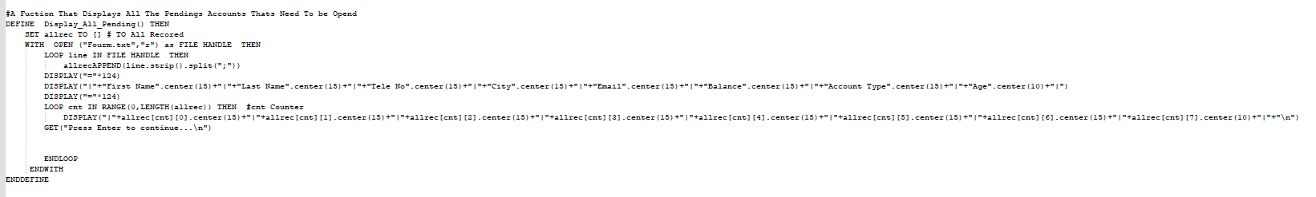

**And This is The Source of This Function:**

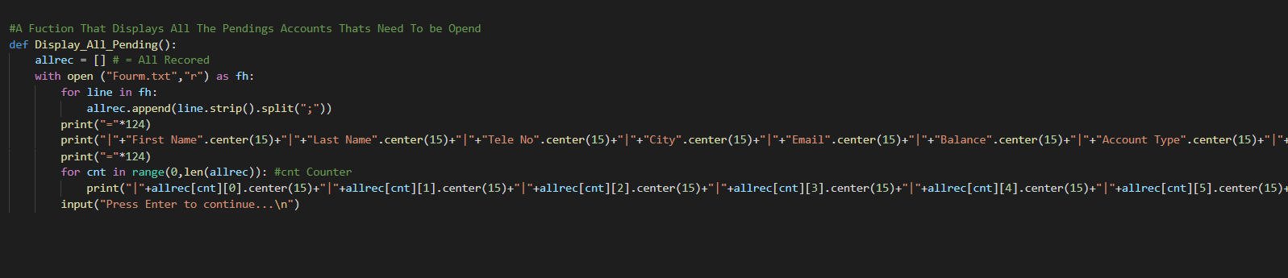

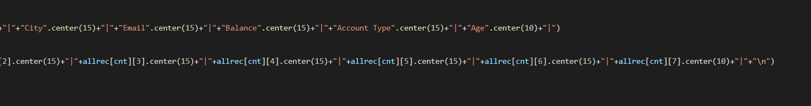

# GENERATE ID:

**This The Flowchart of This Function:**

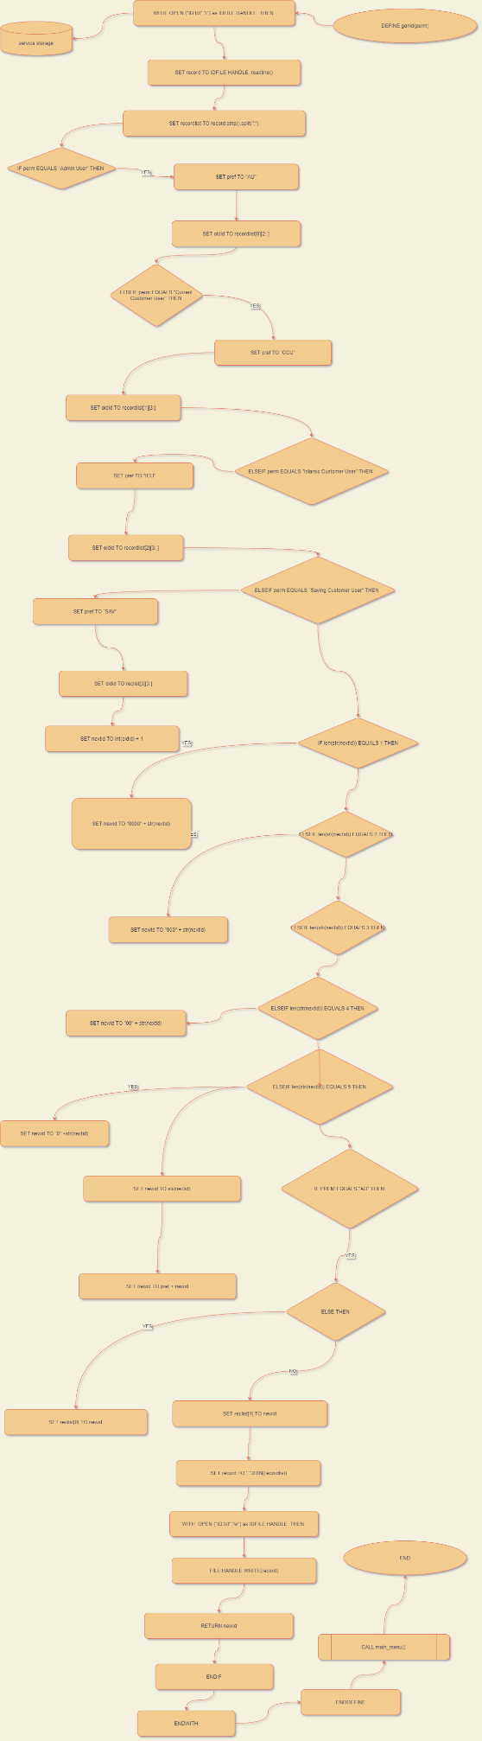

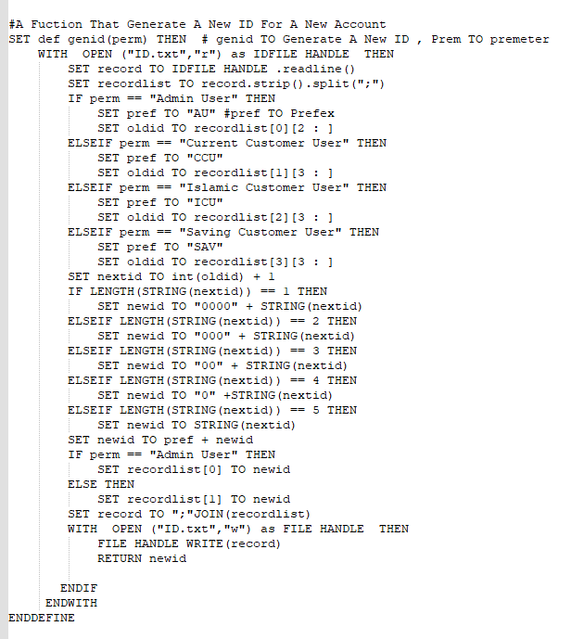**This The Pseudo Code of This Function:**

**And This is The Source of This Function:**

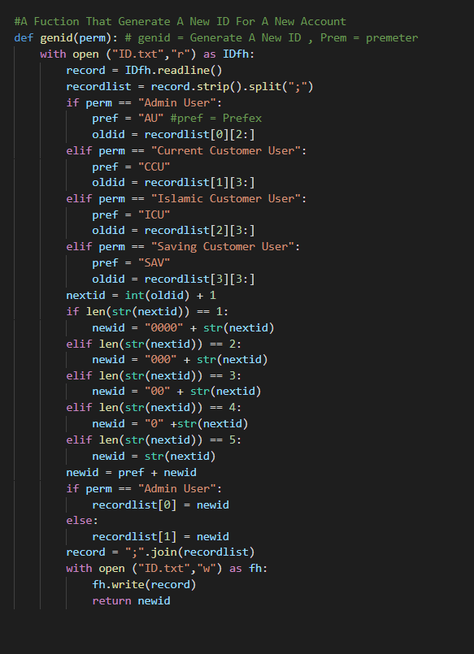

# ADMIN MENU:

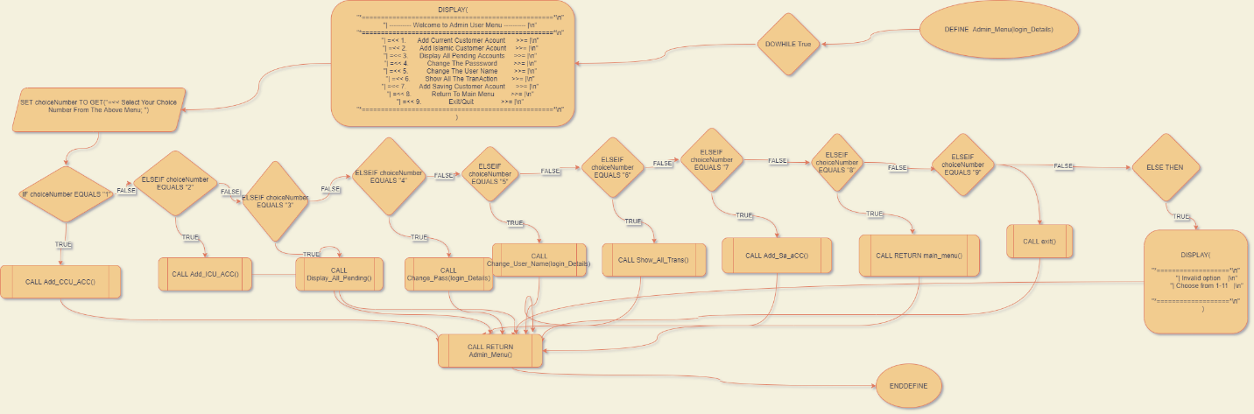**This The Flowchart of This Function:**

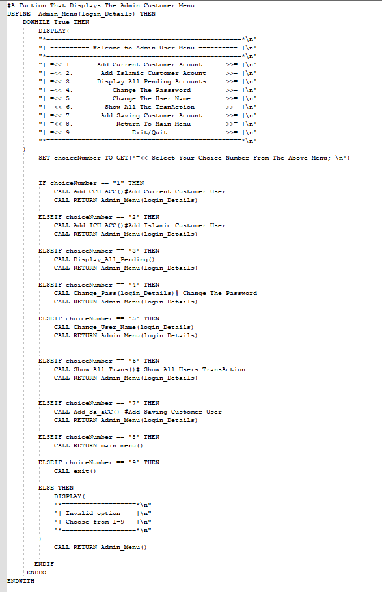**This The Pseudo Code of This Function:**

**And This is The Source of This Function:**

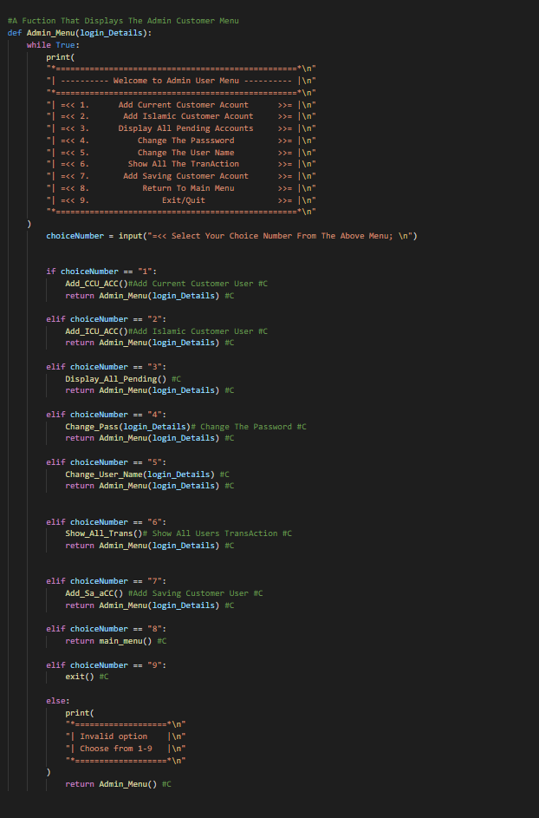

# CURRNCY CONVERTER CALCULATOUR:

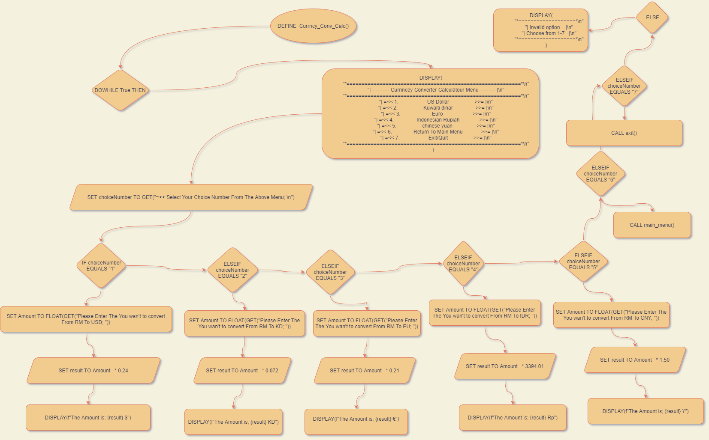**This The Flowchart of This Function:**

**This The Pseudo Code of This Function:**

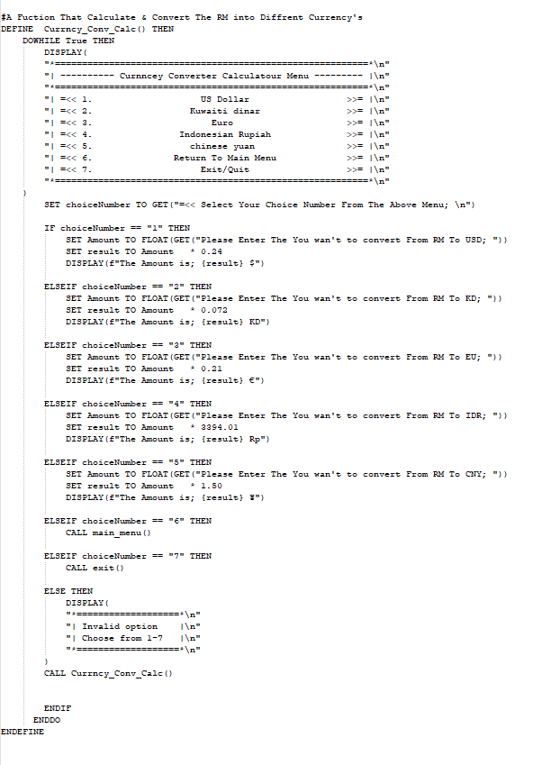

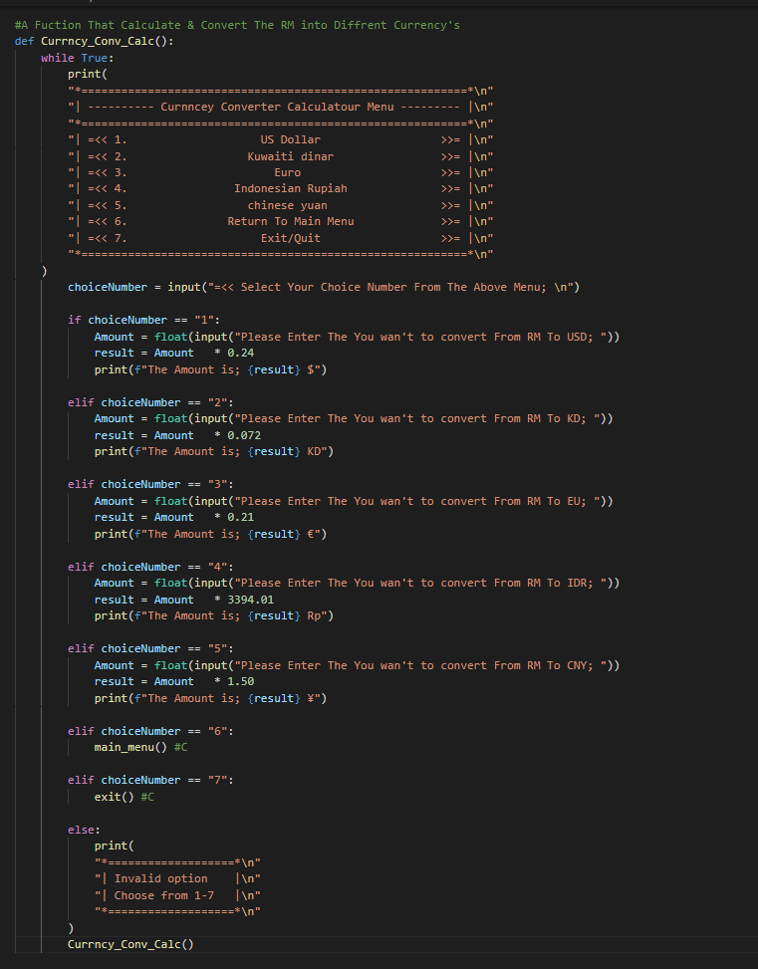**And This is The Source of This Function:**

# CUREENT CUSTOMER MENU:

**This The Flowchart of This Function:**

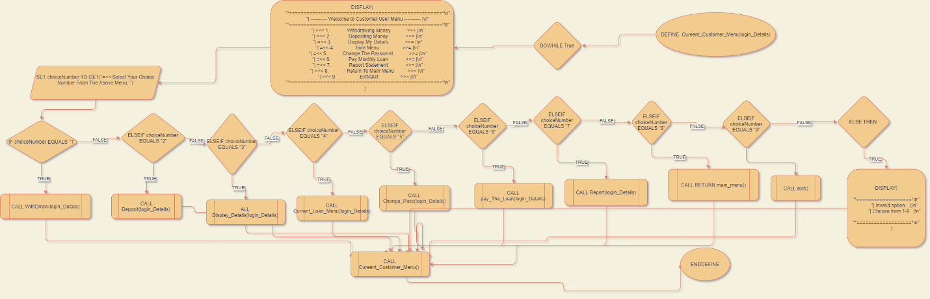

**This The Pseudo Code of This Function:**

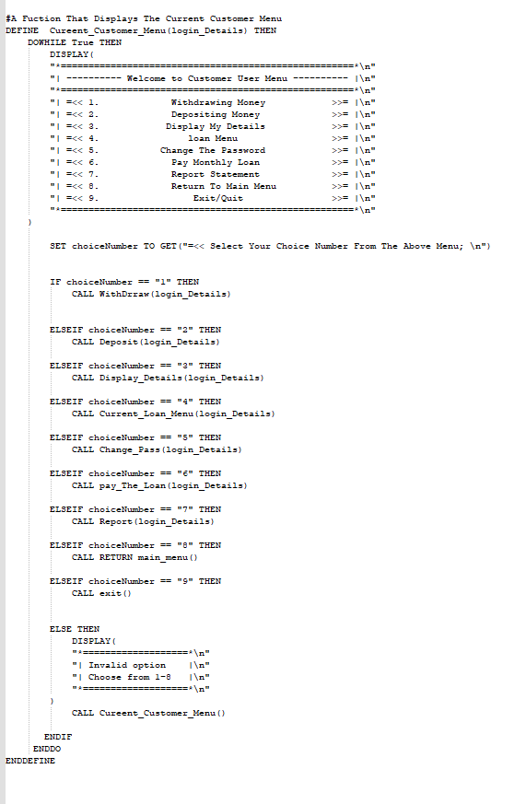

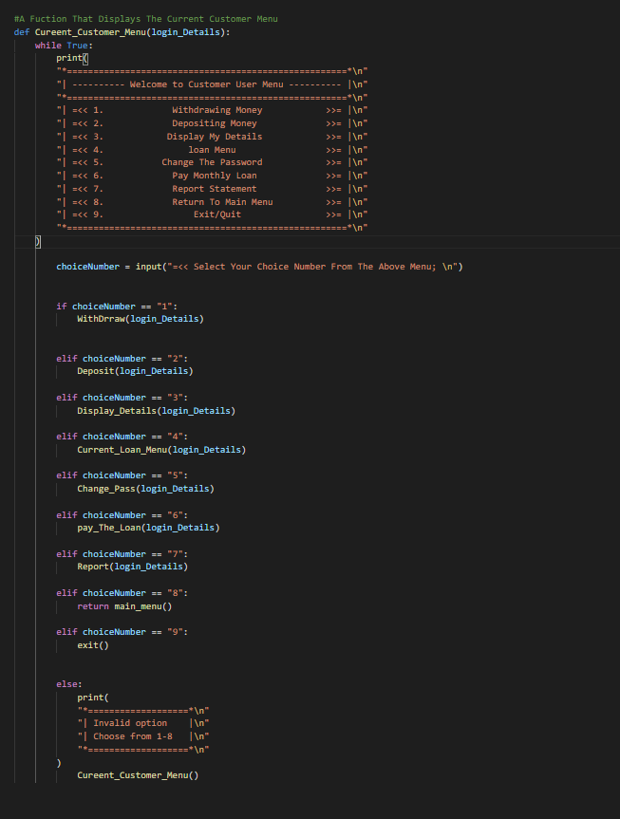**And This is The Source of This Function:**

# ISLAMIC CUSTOMER MENU:

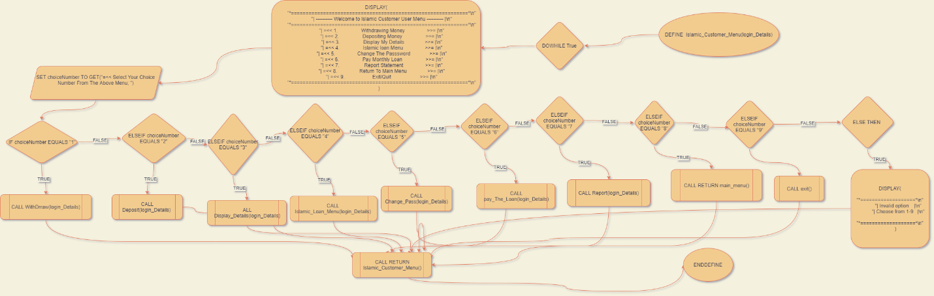**This The Flowchart of This Function:**

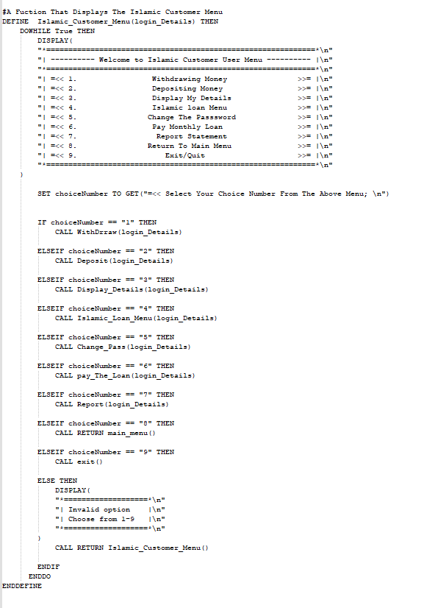**This The Pseudo Code of This Function:**

**And This is The Source of This Function:**

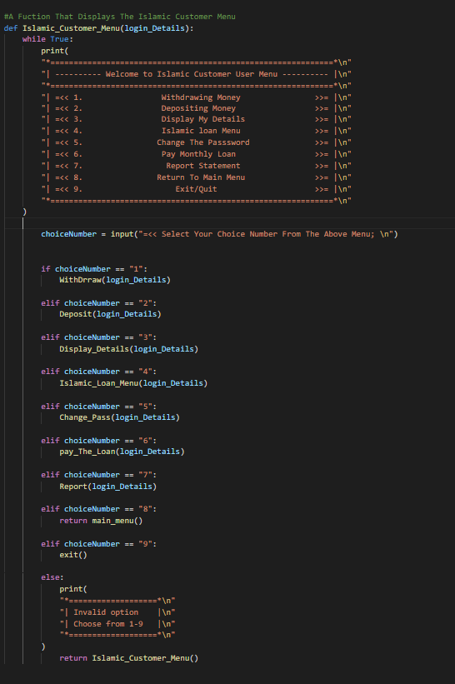

# DISPLAY DETAILS:

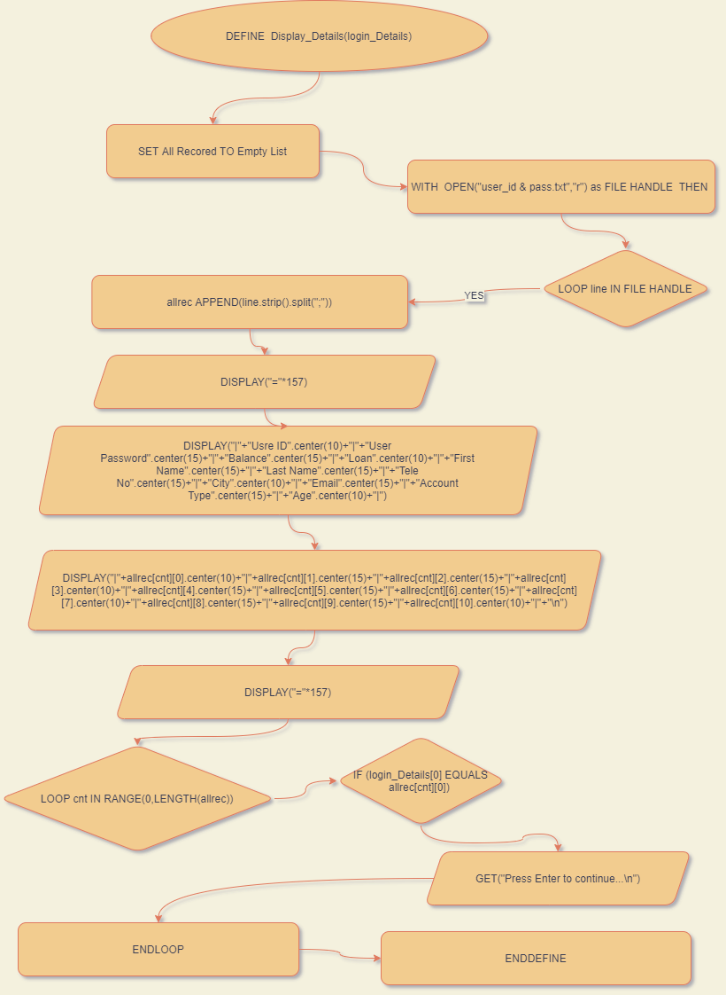**This The Flowchart of This Function:**

**This The Pseudo Code of This Function:**

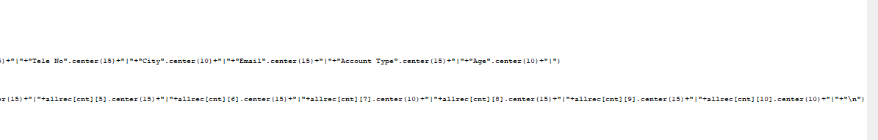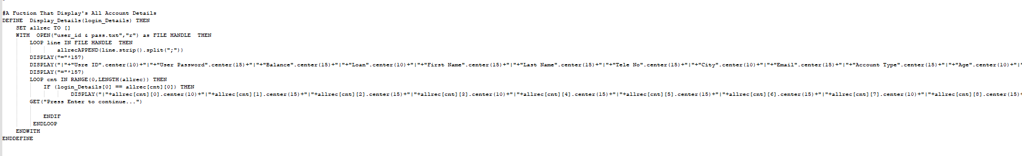

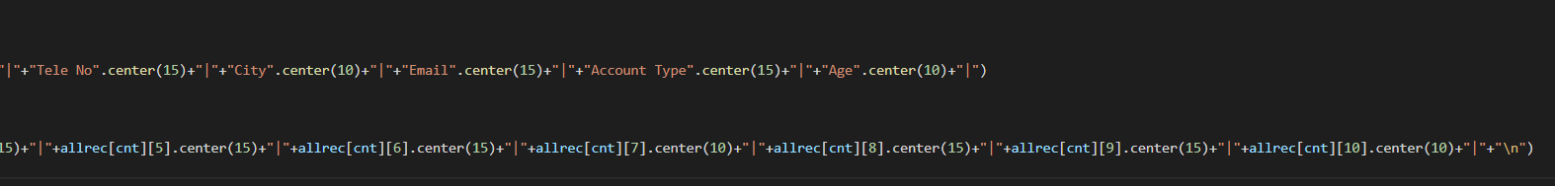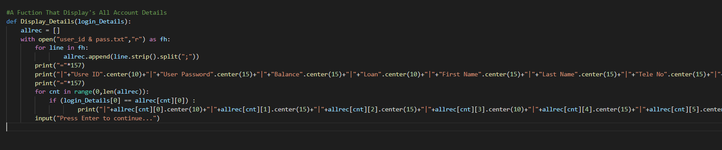**And This is The Source of This Function:**

# SAVING ACCOUNT MENU:

**This The Flowchart of This Function:**

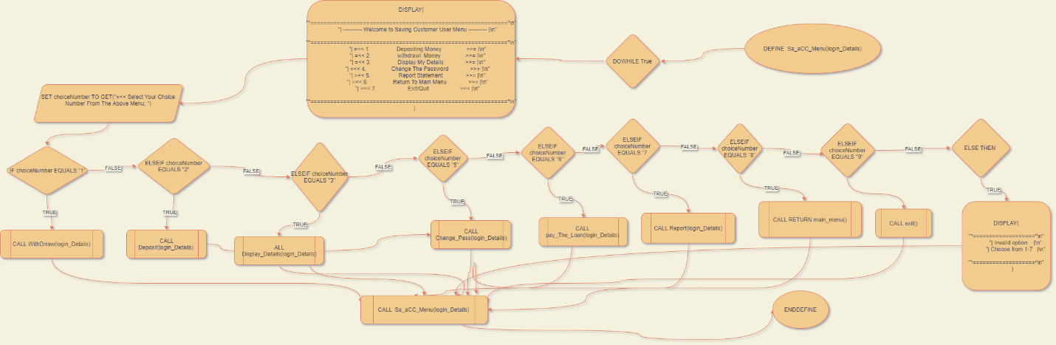

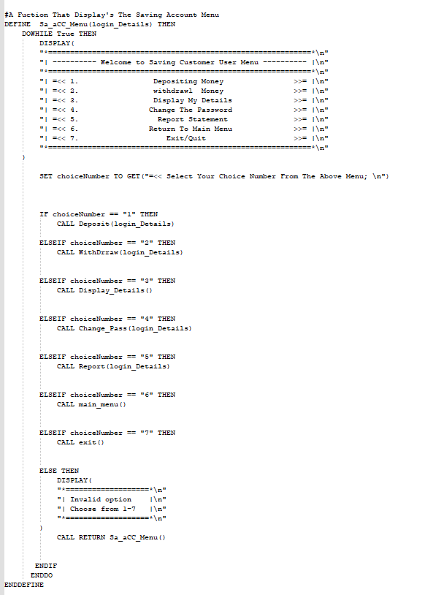**This The Pseudo Code of This Function:**

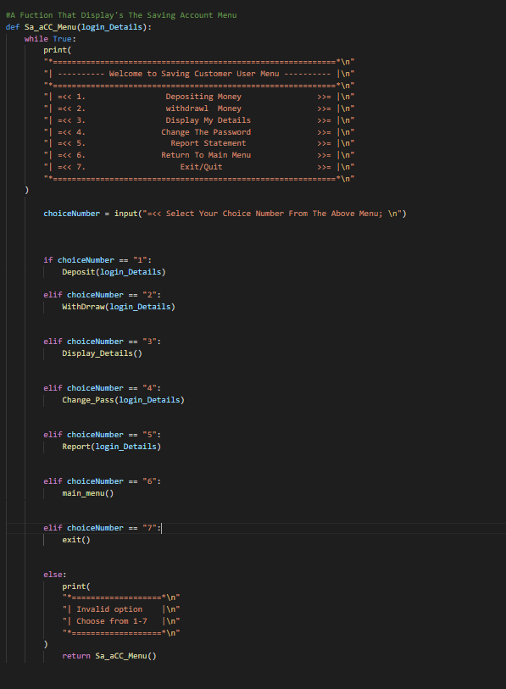**And This is The Source of This Function:**

# WITHDRRAW:

**This The Flowchart of This Function:**

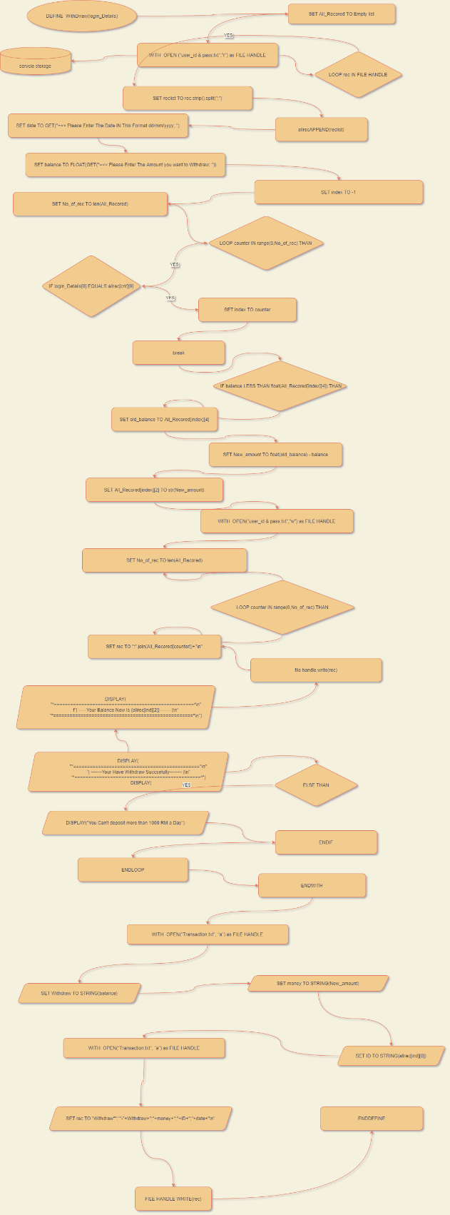

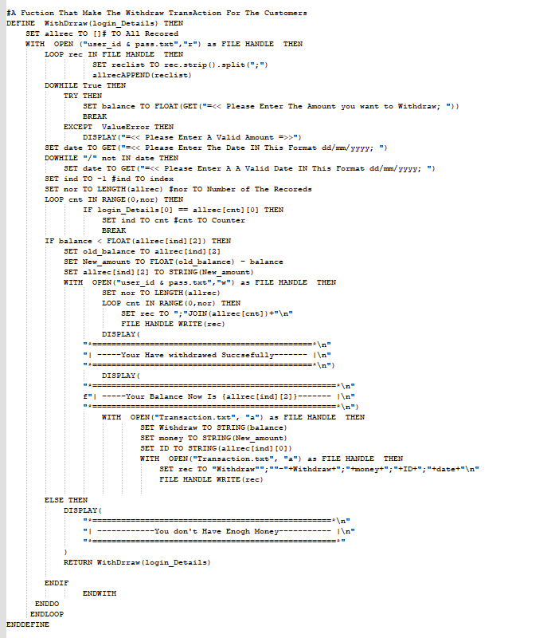**This The Pseudo Code of This Function:**

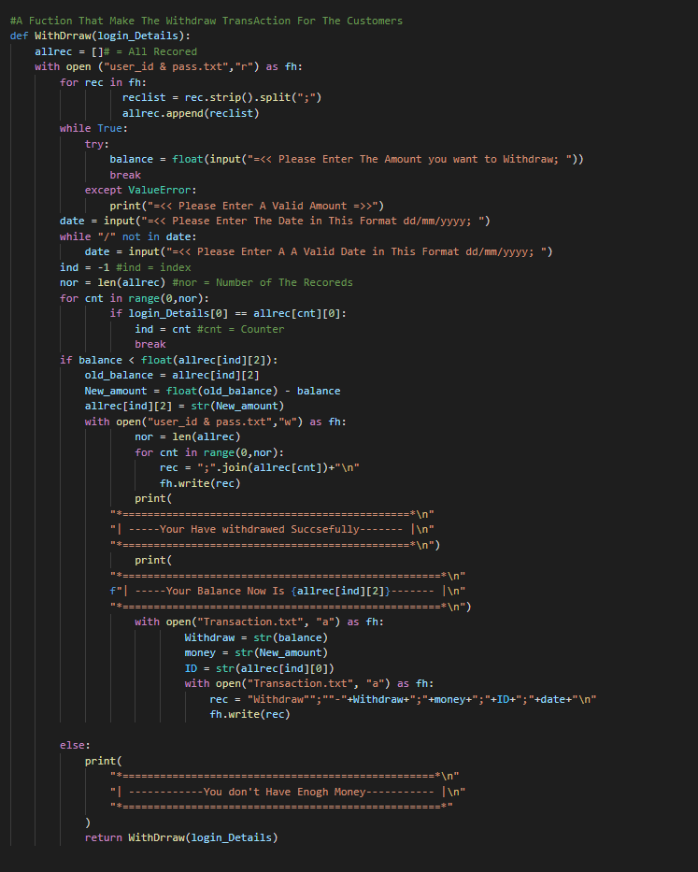**And This is The Source of This Function:**

# DEPOSIT:

**This The Flowchart of This Function:**

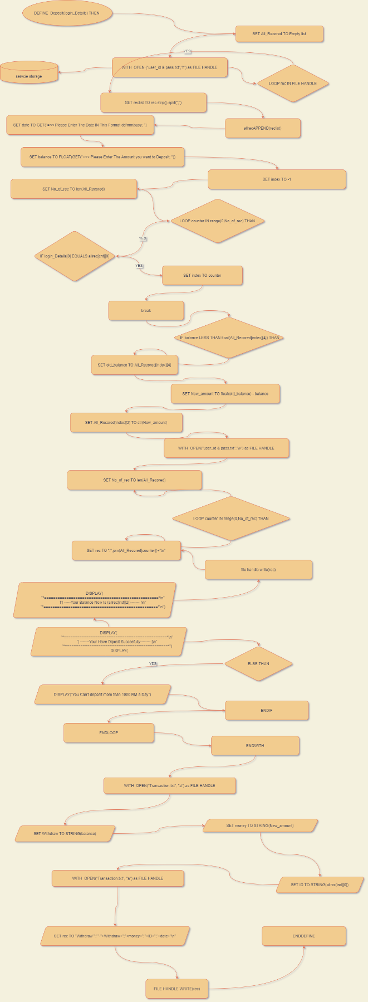

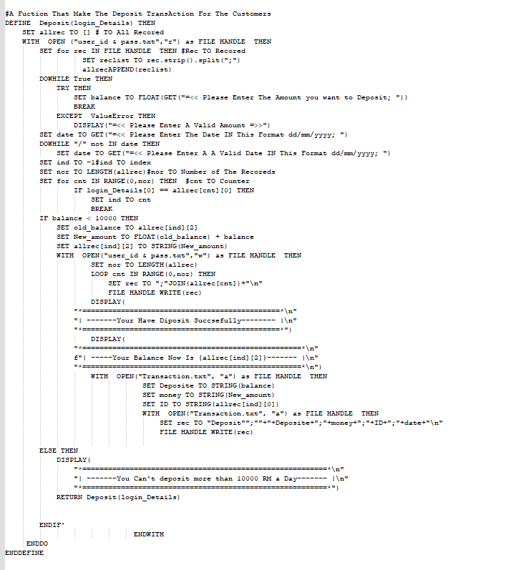**This The Pseudo Code of This Function:**

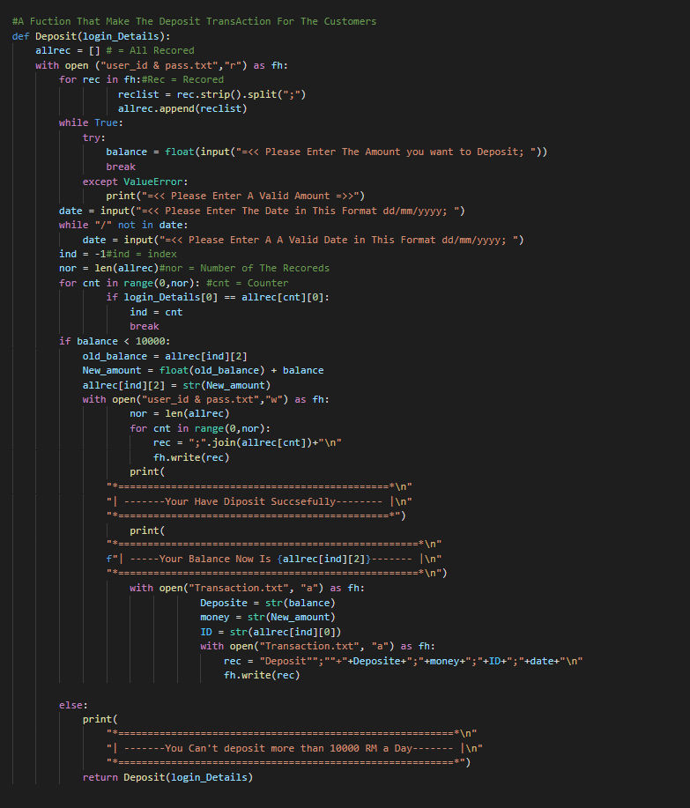**And This is The Source of This Function:**

# CHANGE PASSWORD:

**This The Flowchart of This Function:**

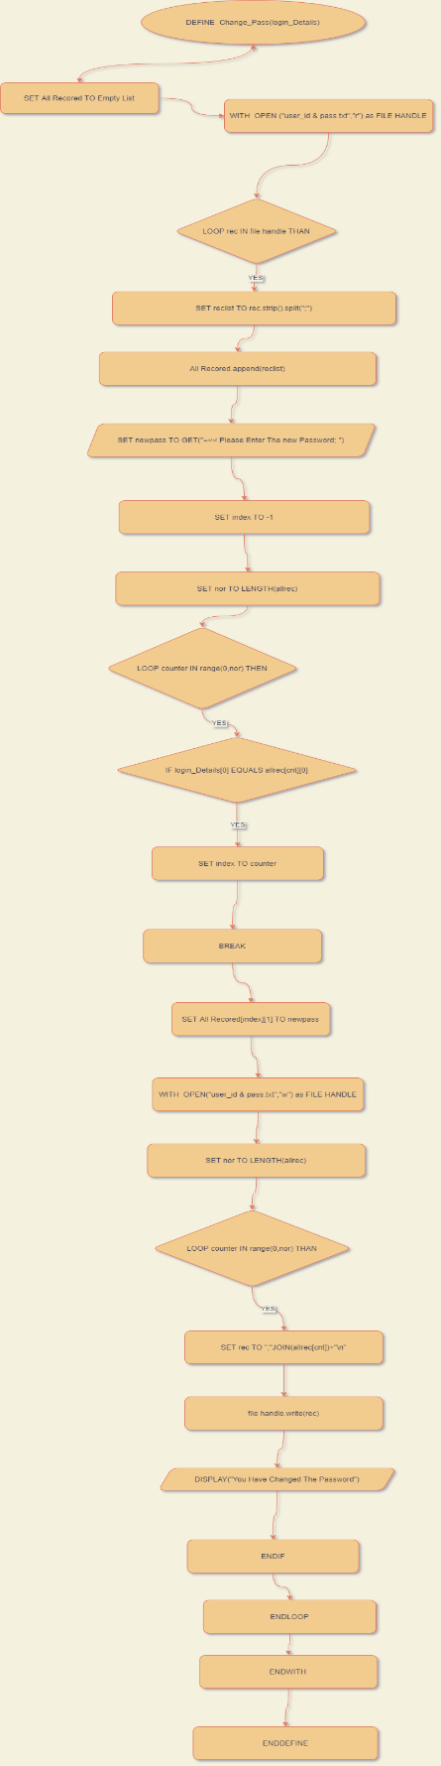

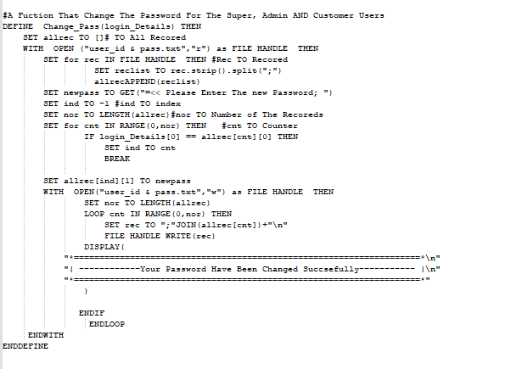**This The Pseudo Code of This Function:**

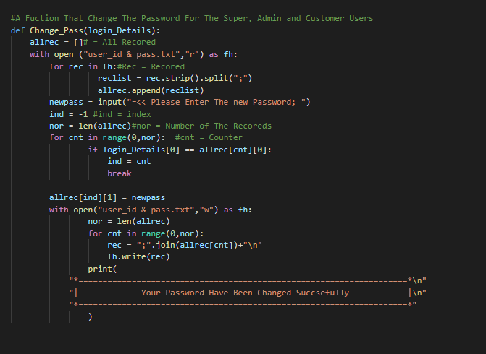**And This is The Source of This Function:**

# CHANGE USERNAME:

**This The Flowchart of This Function:**

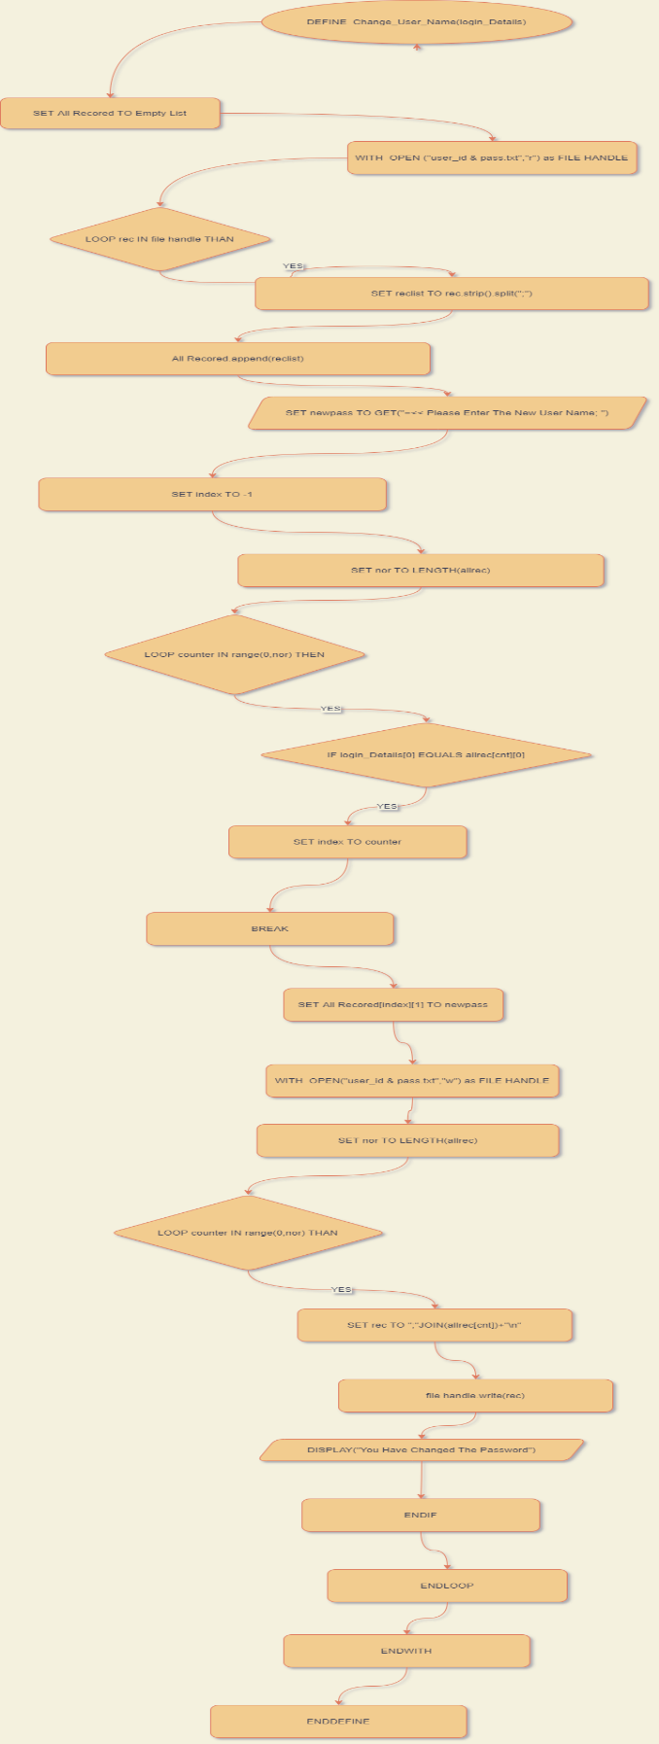

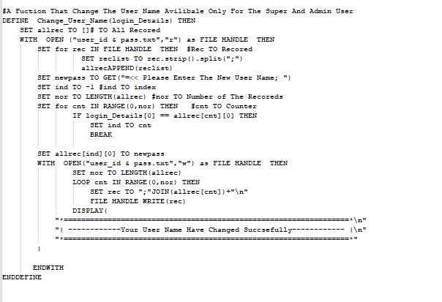**This The Pseudo Code of This Function:**

**And This is The Source of This Function:**

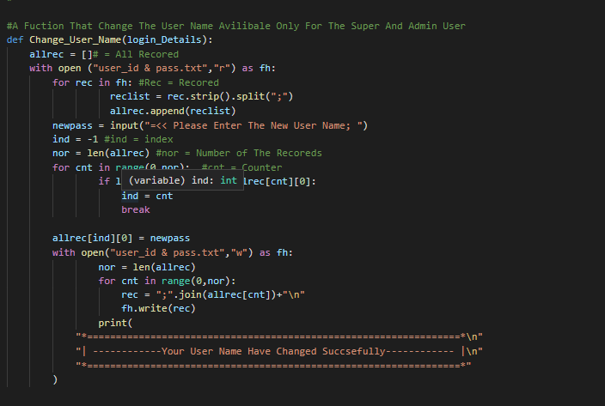

# CURRENT LOAN MENU:

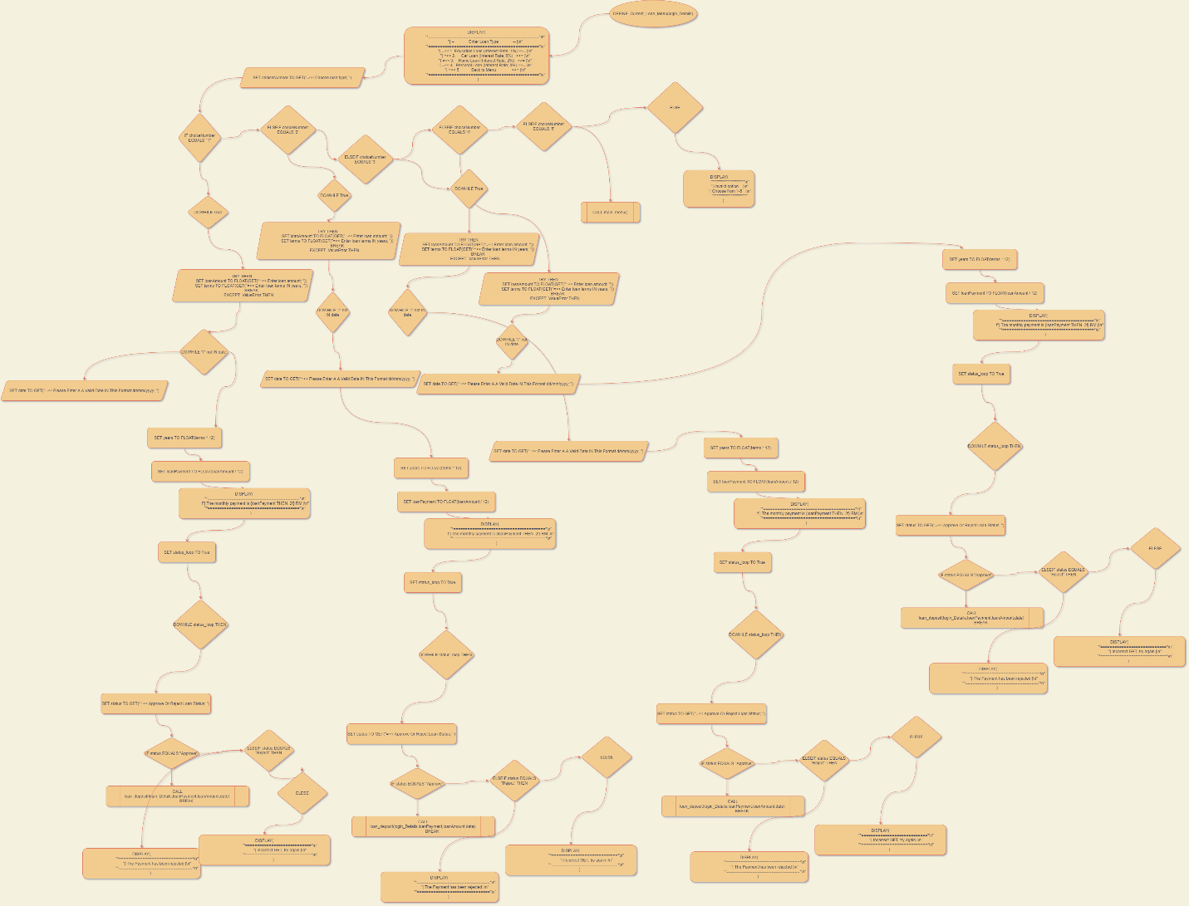**This The Flowchart of This Function:**

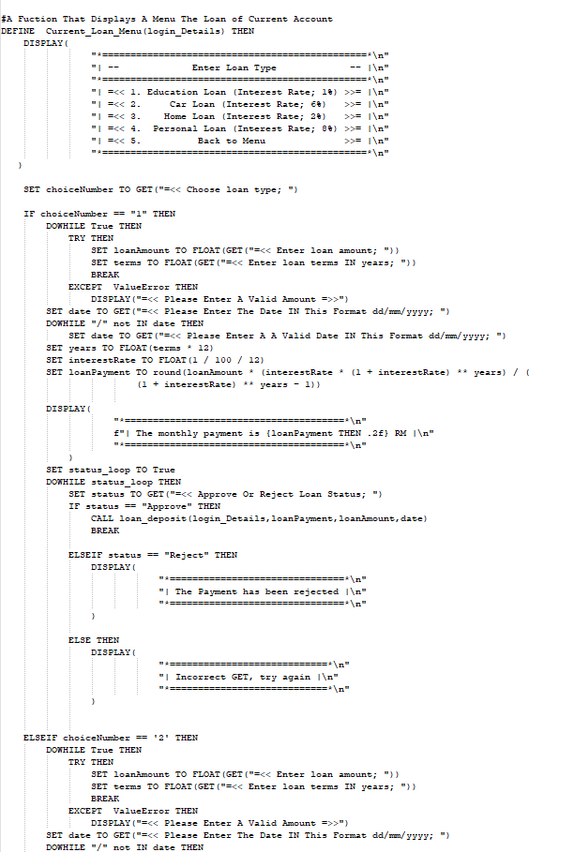**This The Pseudo Code of This Function:**

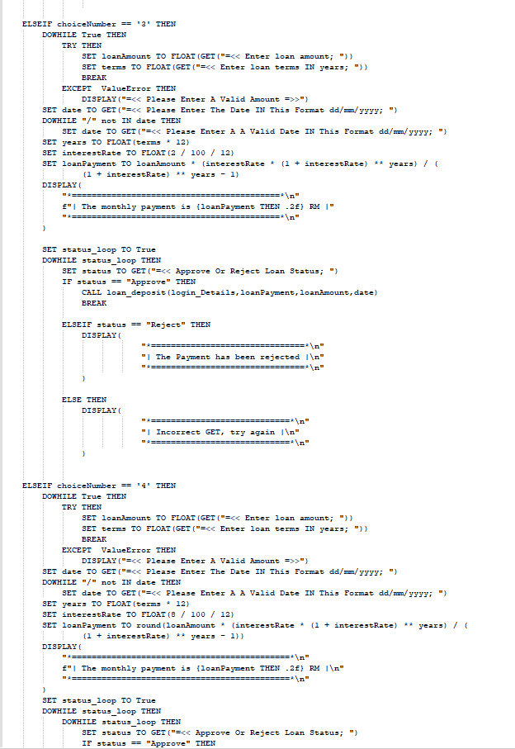

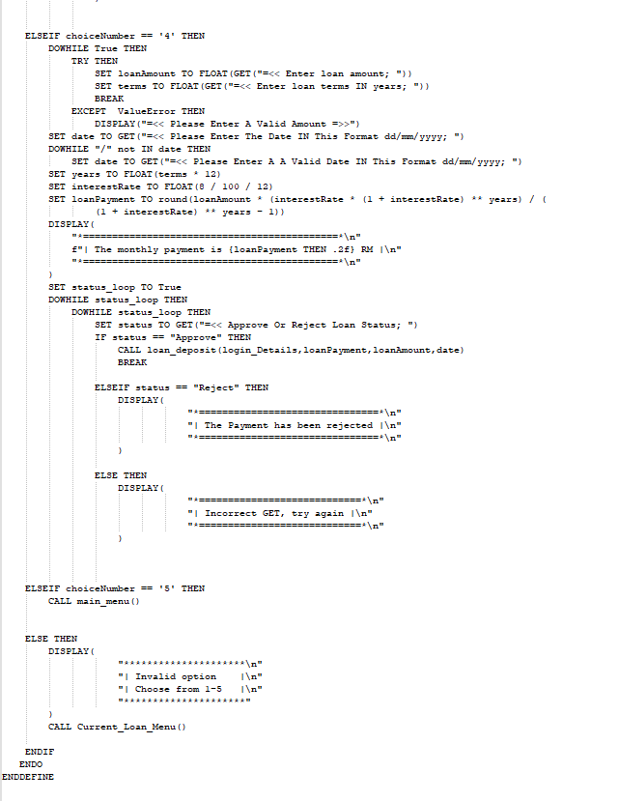

**And This is The Source of This Function:**

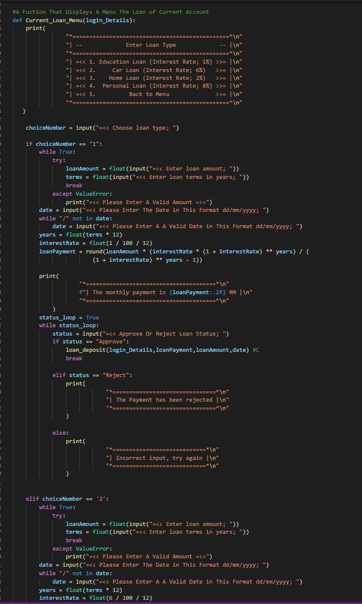

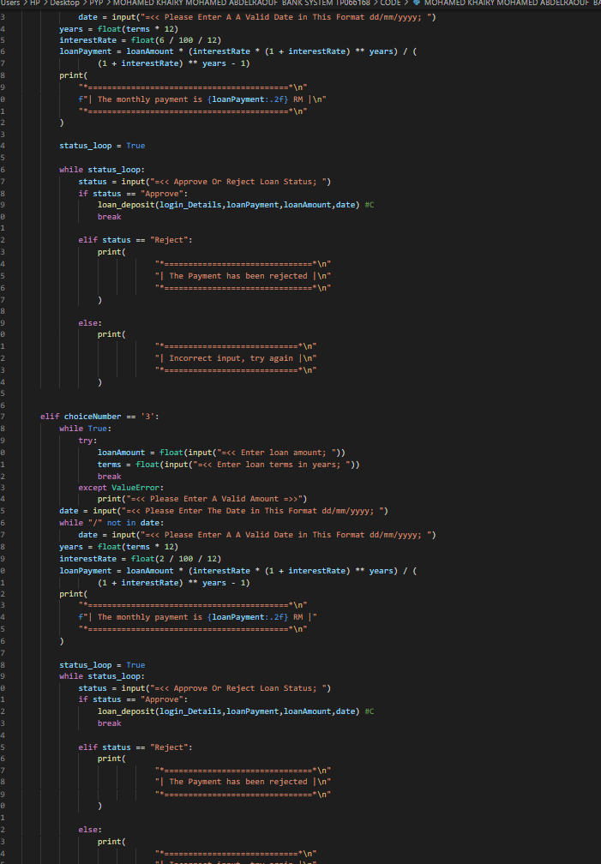

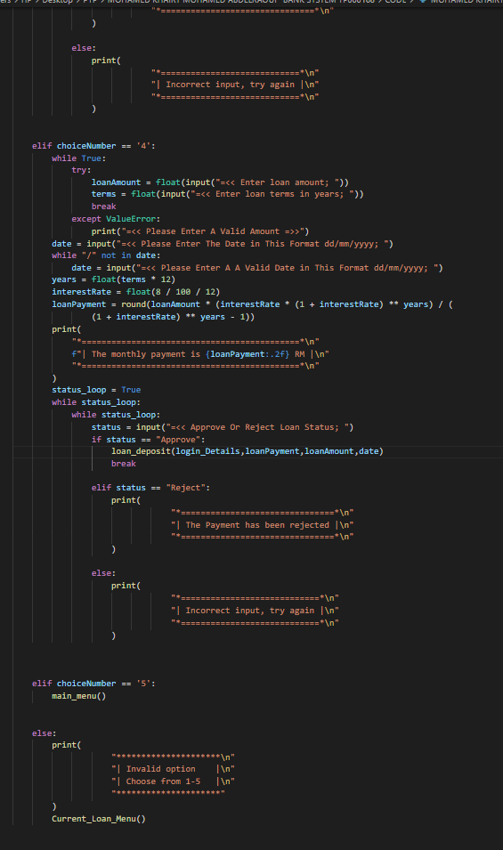

# ISLAMIC LOAN MENU:

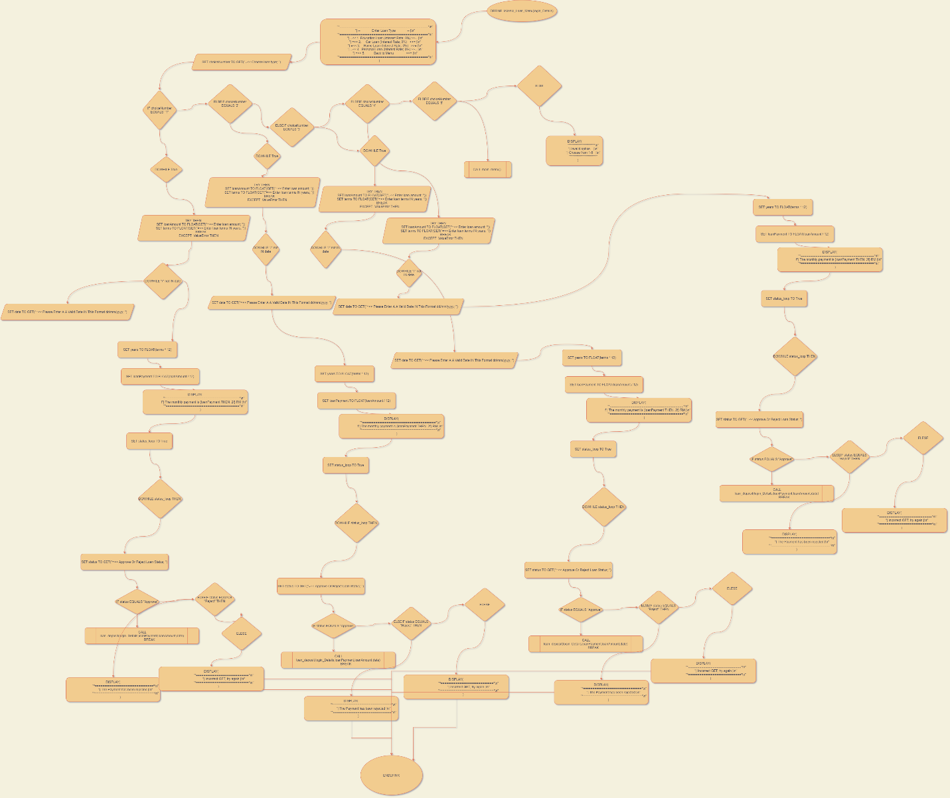**This The Flowchart of This Function:**

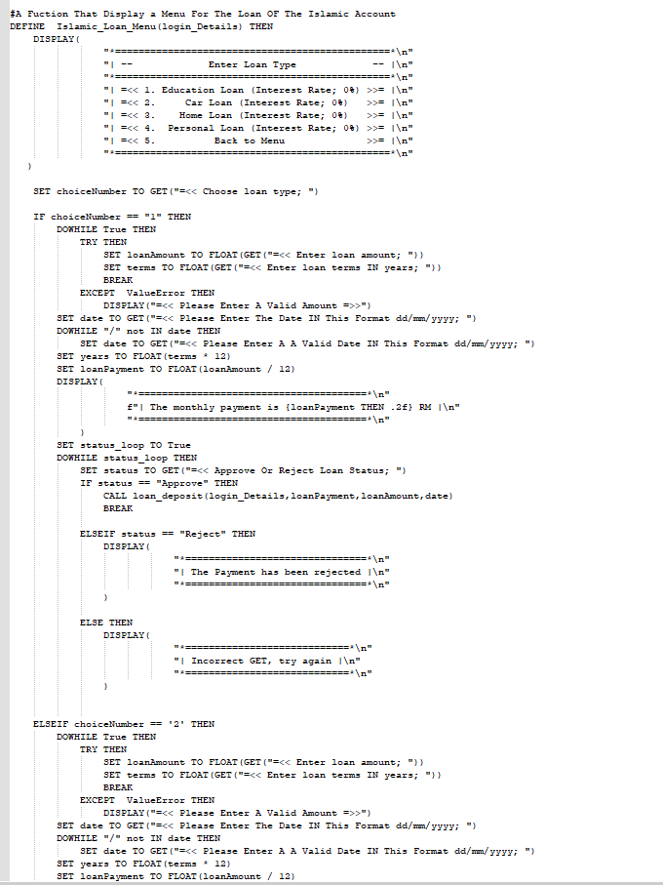**This The Pseudo Code of This Function:**

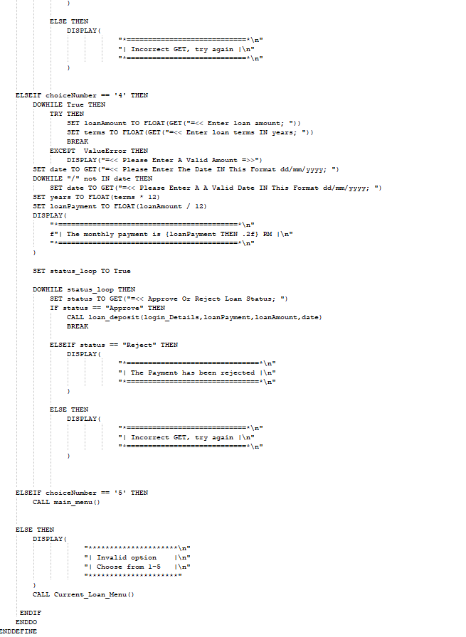

**And This is The Source of This Function:**

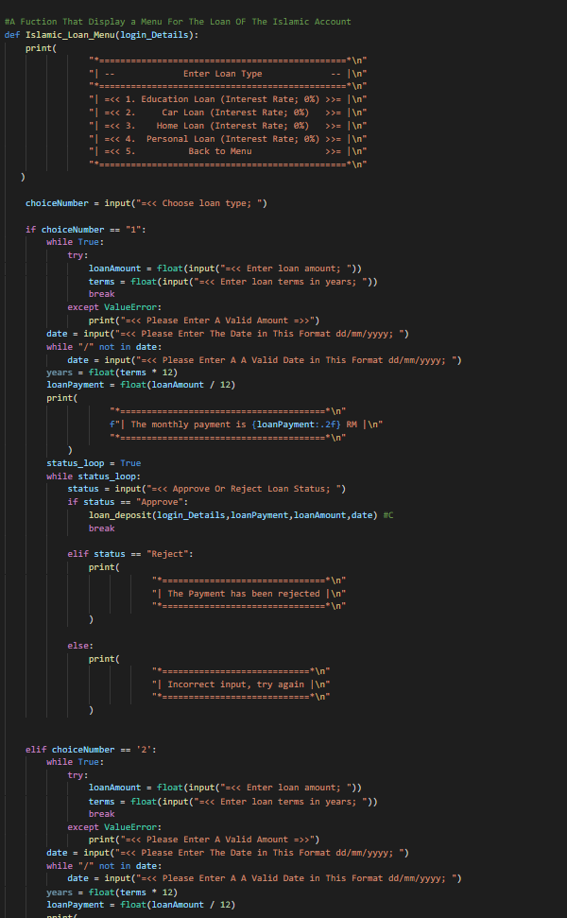

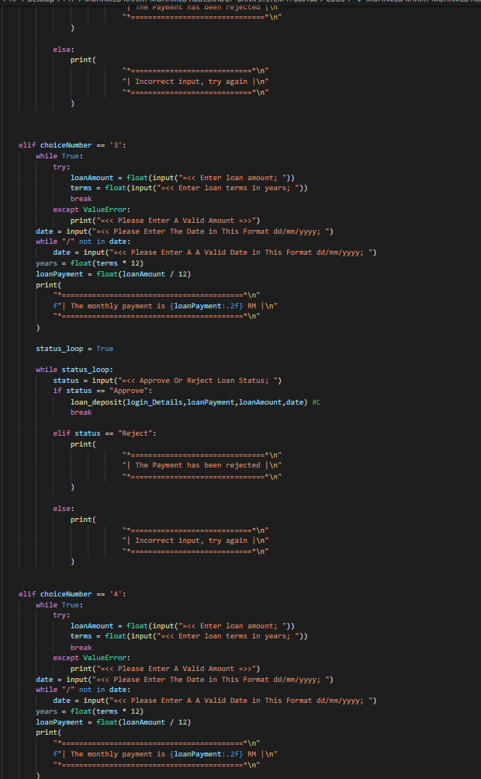

# LOAN DEPOSIT:

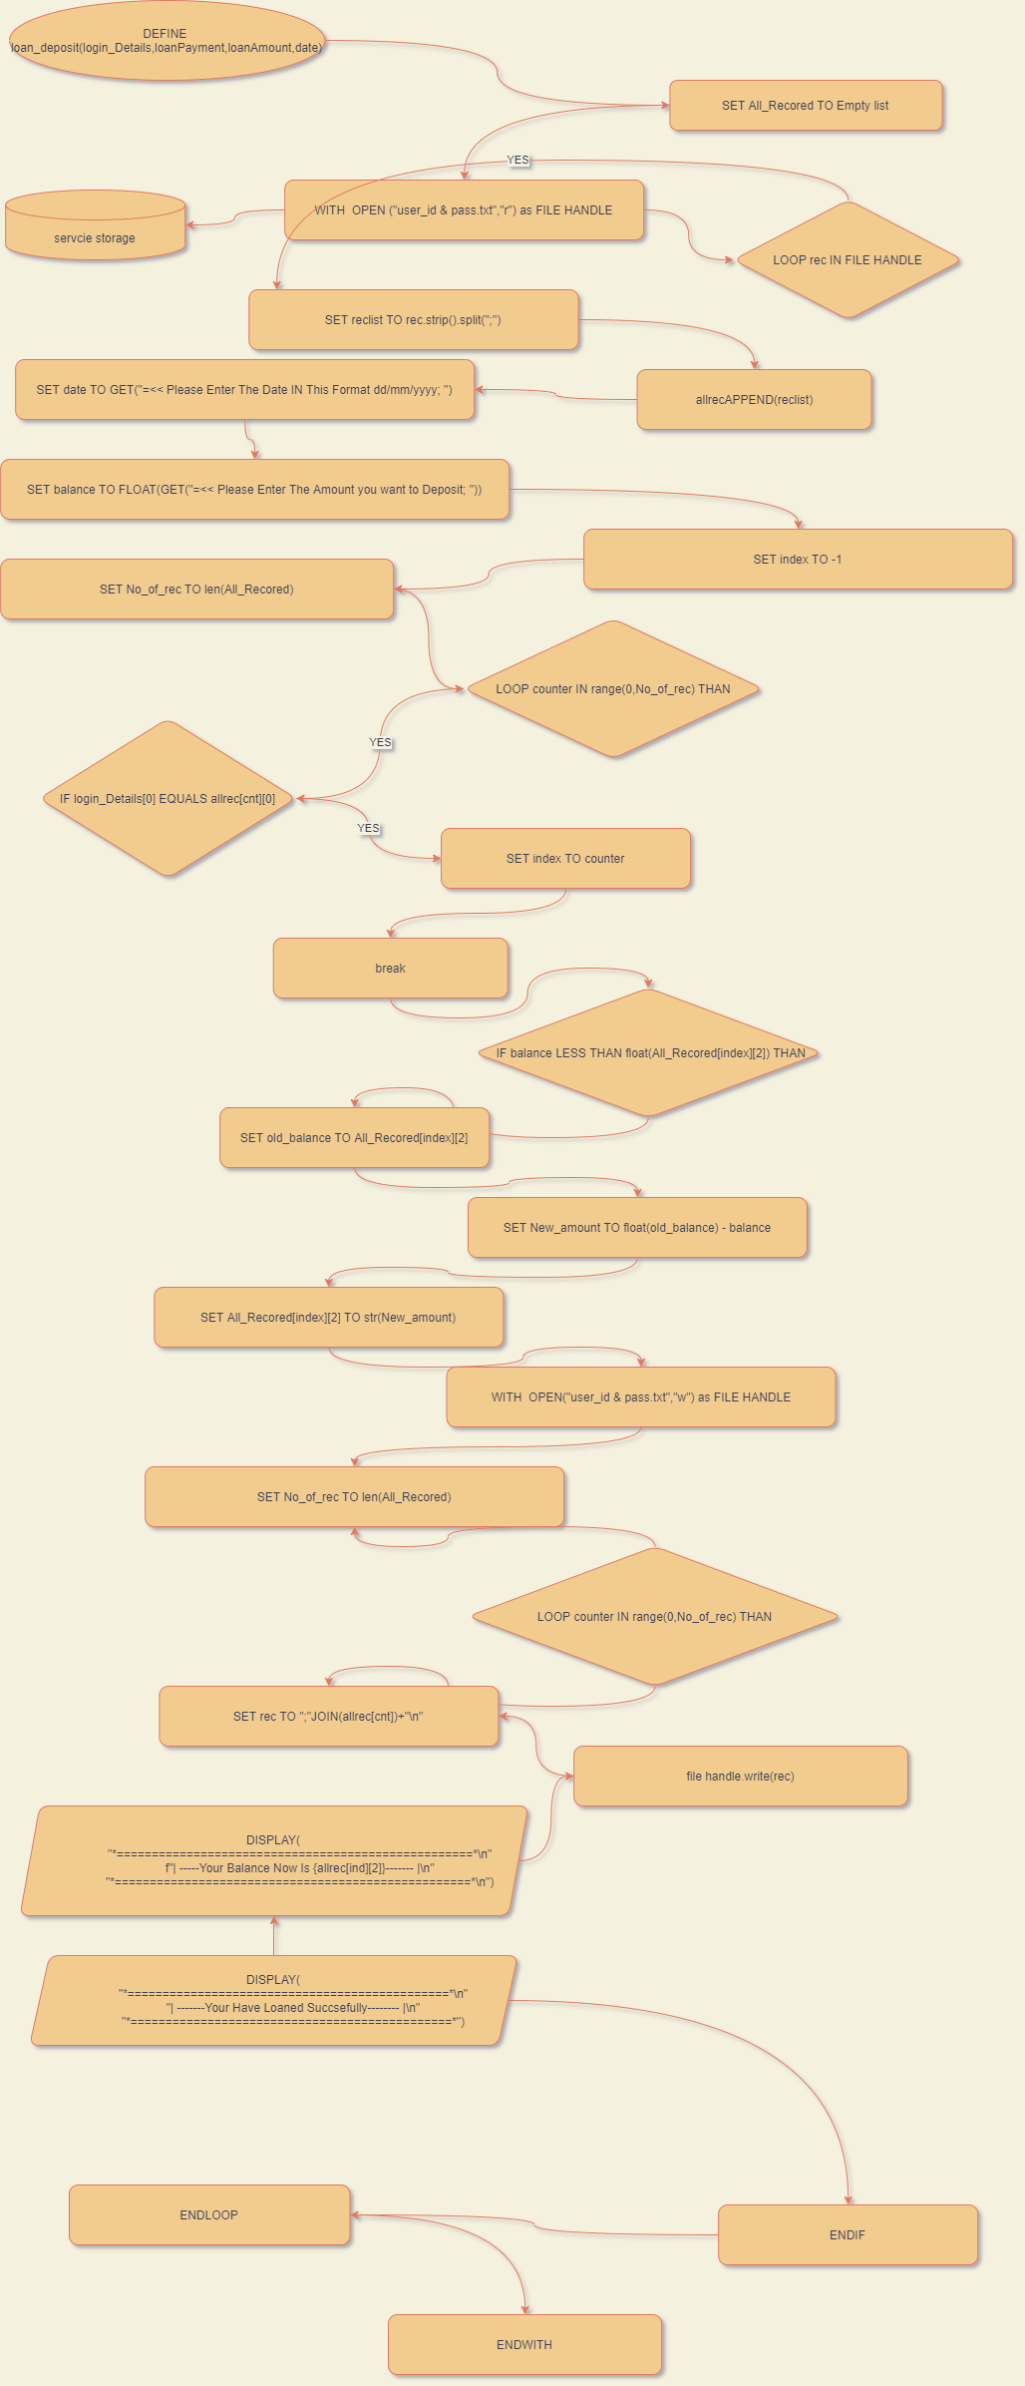**This The Flowchart of This Function:**

**This The Pseudo Code of This Function:**

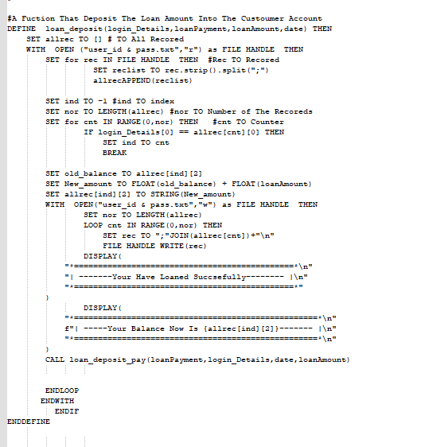

**And This is The Source of This Function:**

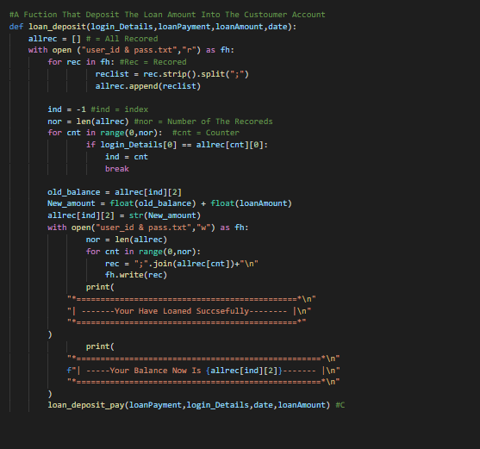

# LOAN DEPOSIT PAY:

**This The Flowchart of This Function:**

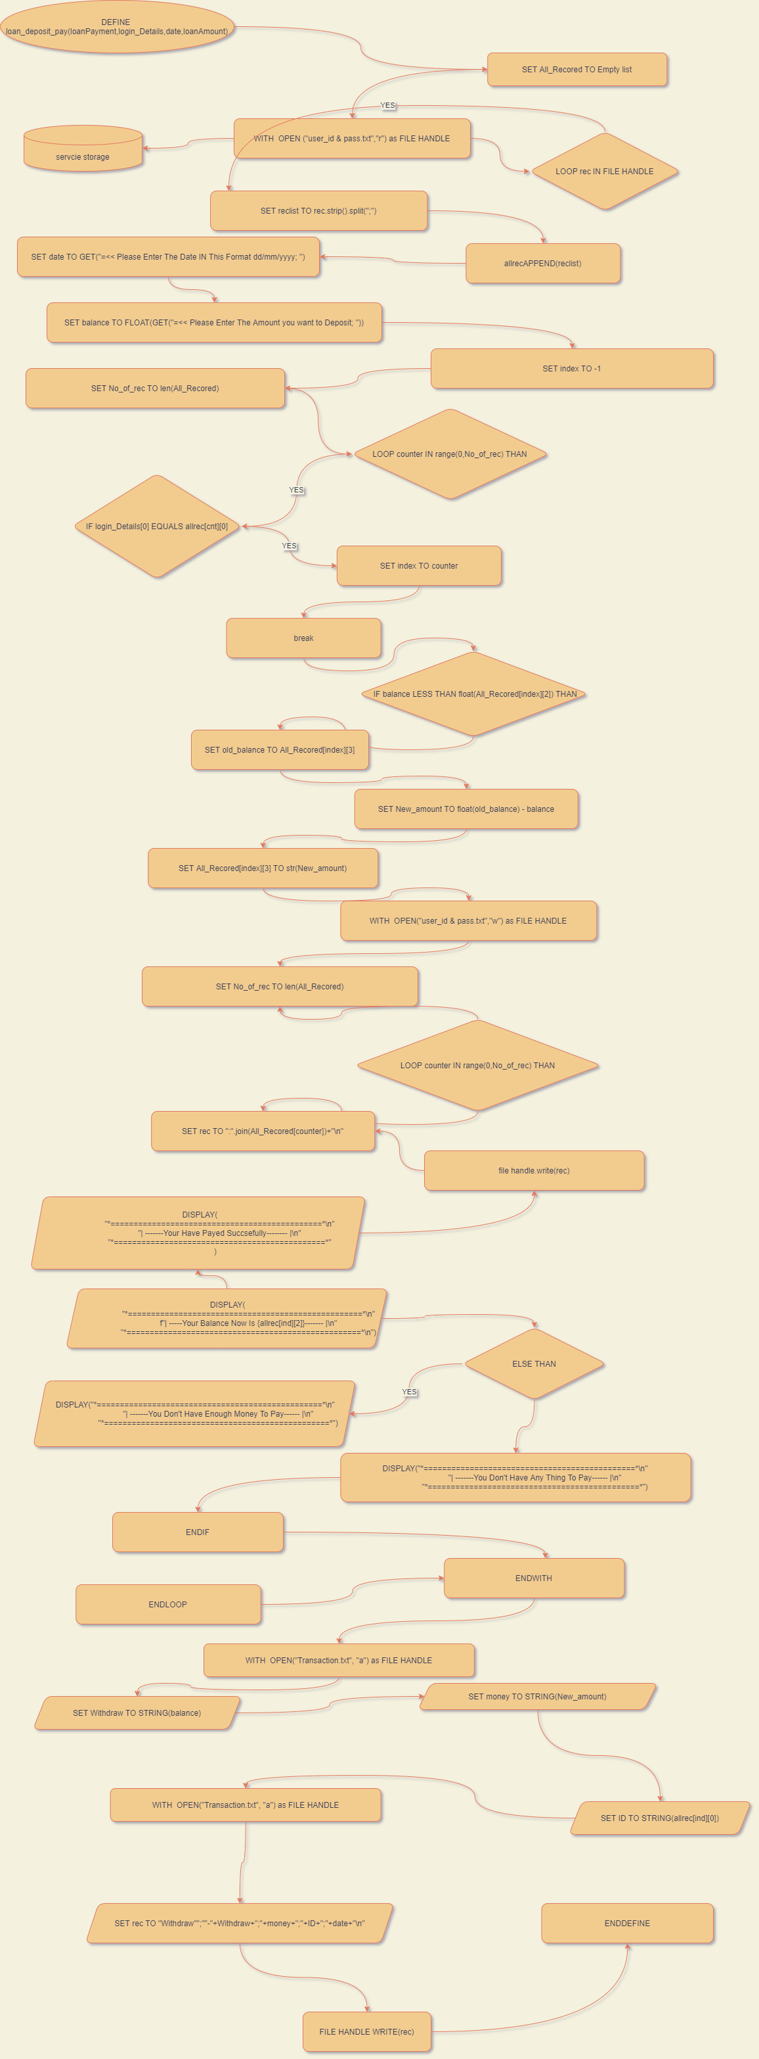

**This The Pseudo Code of This Function:**

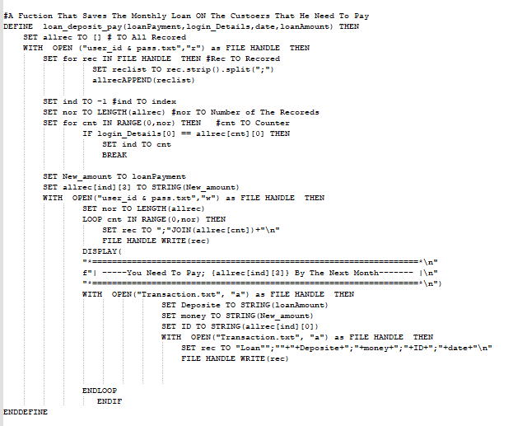

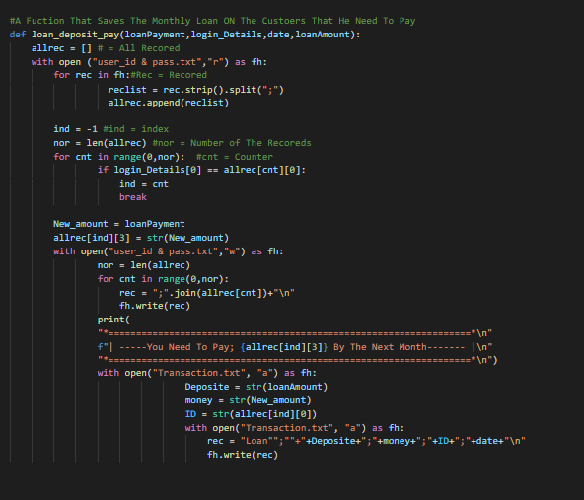**And This is The Source of This Function:**

# PAY THE LOAN:

**This The Flowchart of This Function:**

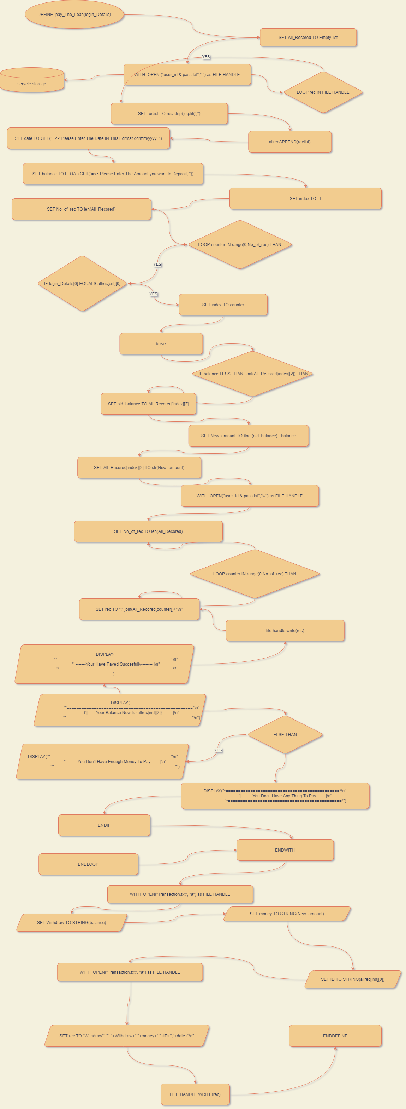

**This The Pseudo Code of This Function:**

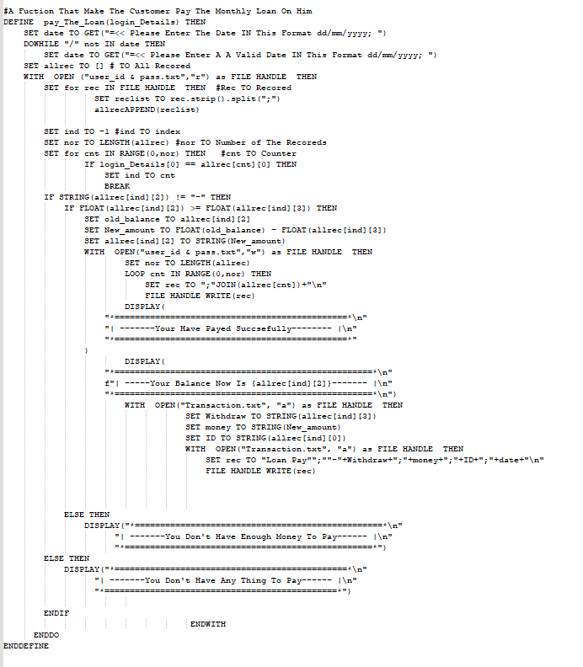

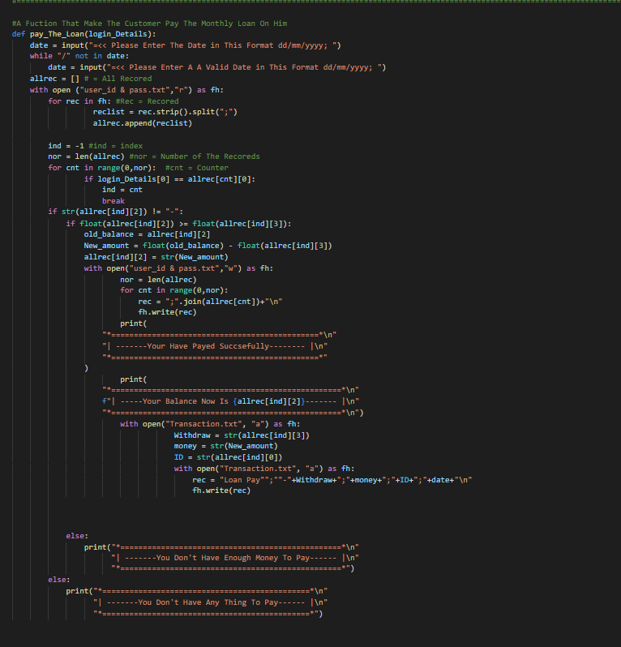**And This is The Source of This Function:**

# REPORT:

**This The Flowchart of This Function:**

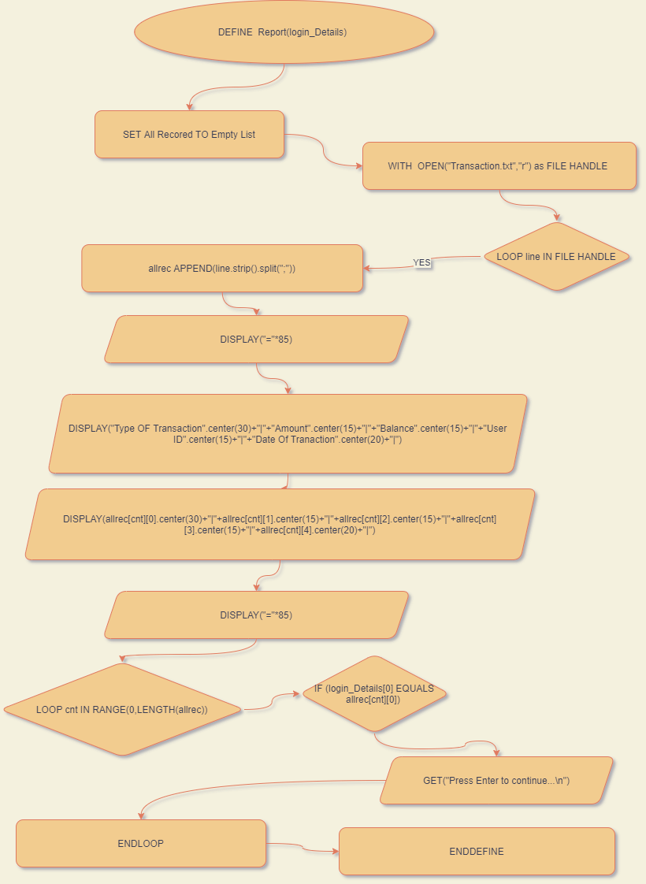

**This The Pseudo Code of This Function:**

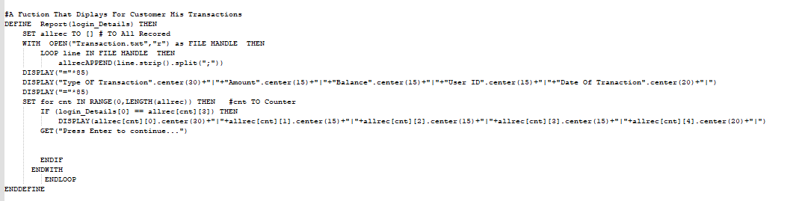

**And This is The Source of This Function:**

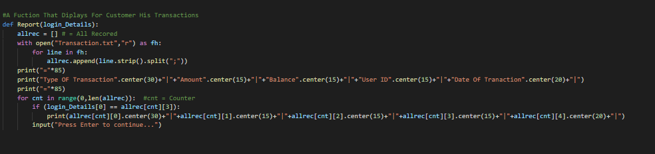

# SHOW ALL TRANS:

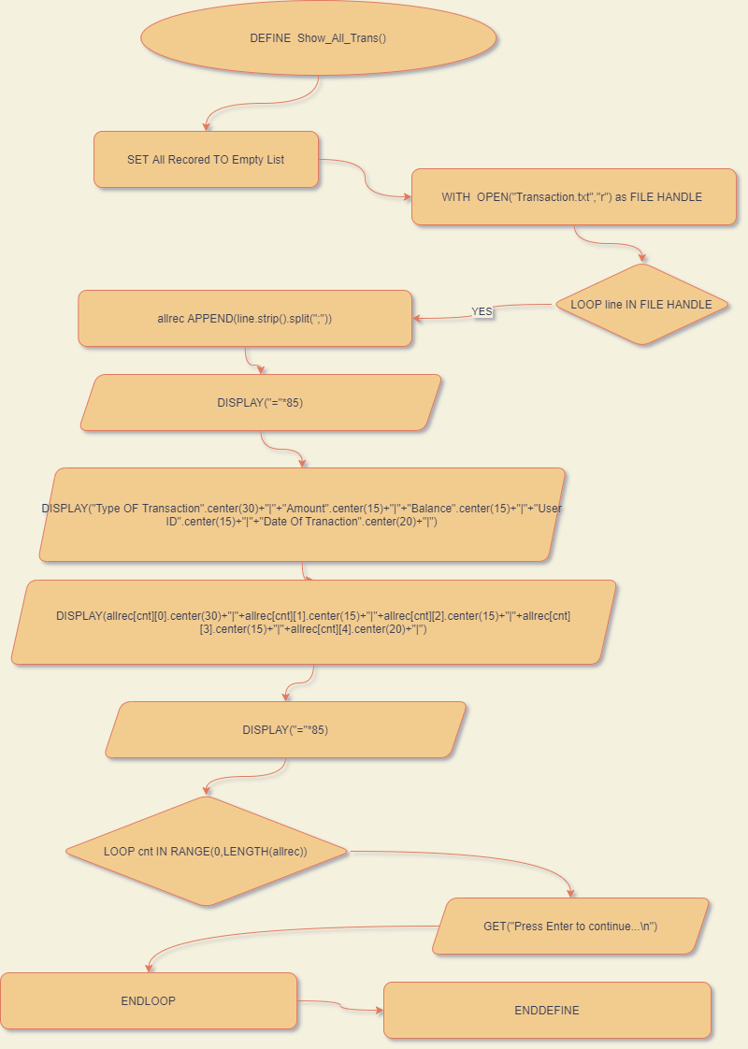**This The Flowchart of This Function:**

**This The Pseudo Code of This Function:**

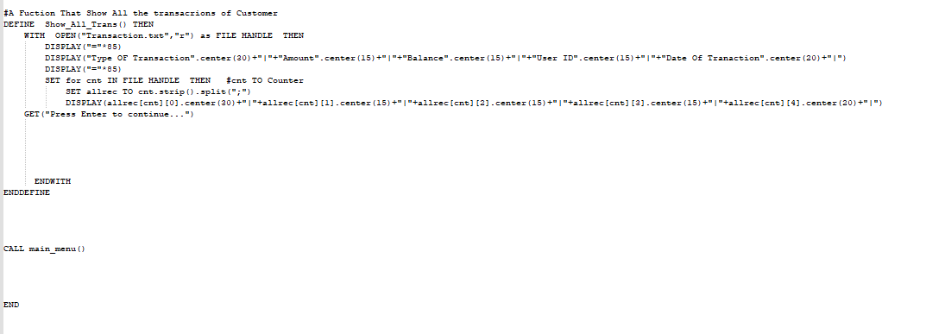

**And This is The Source of This Function:**

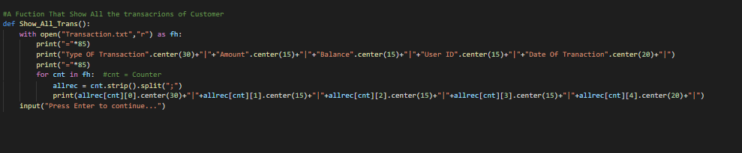

# Data Validation

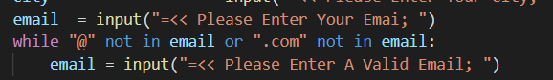

“not in” can check whether or not the “@” and “.com” gift within the variable email. It returns “True” price if the “@” and “.com” isn't gift within the variable and asks the user to input the worth once more. If each of them is gift within the variable, the program won't raise the user to input once more

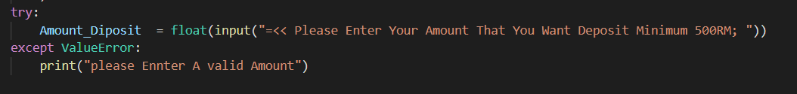

I have Used try and except To Force the User to Enter Numbers Only

And Above of Thim While Loop To loop Until They Enter A valid input

I’ve searched about the isdigit() & istring() But I didn’t understand them well, so I decided to use a method That am sure about it

I’ve Used float() instead of integer to avoid any error if the user has enter a decimal Number



I’ve used str() To convert any Float or integer Value into string, so it doesn’t give me error while saving it as a list in a file

I Didn’t use any library because it’s not allowed

So, I made the user to enter the date manually

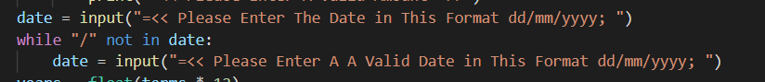

I’ve Forced the User To use / in the format of The Date

And I’ve given the way to write the date, but he is not forced to write the date in This Format

# These are some Samples of The Out put and input

**MAIN MENU:**

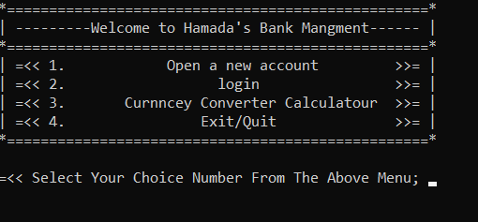

**OPEN ACCOUNT MENU:**

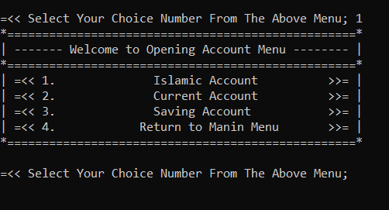

**ISLAMIC OPEN ACCOUNT:**

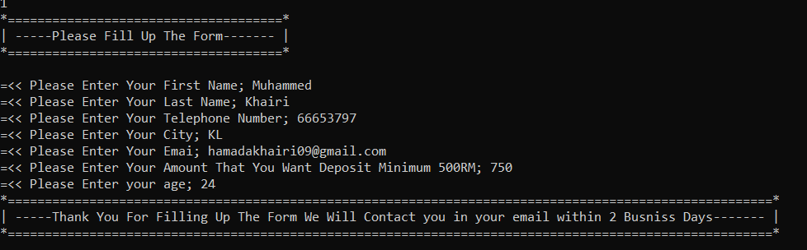

**CURRENT OPEN ACCOUNT:**

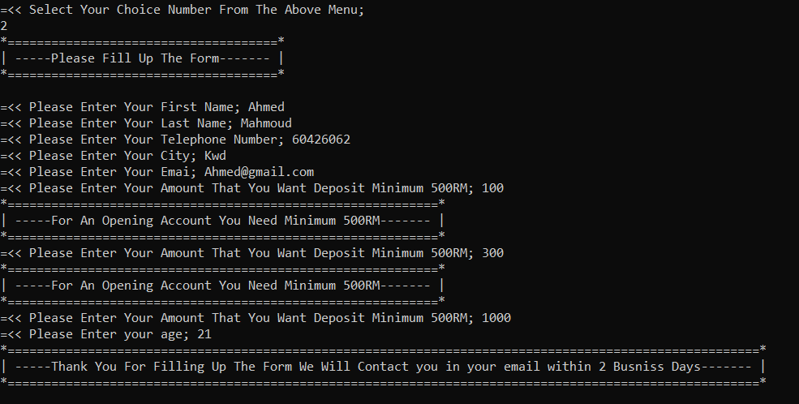

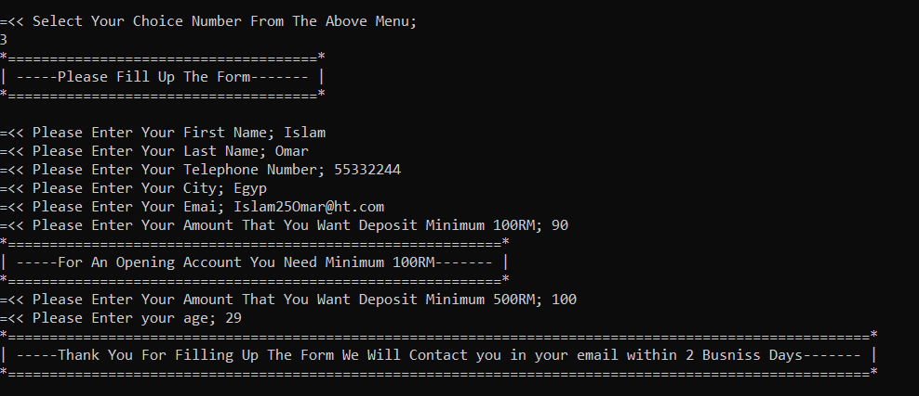**SAVING OPEN ACCOUNT:**

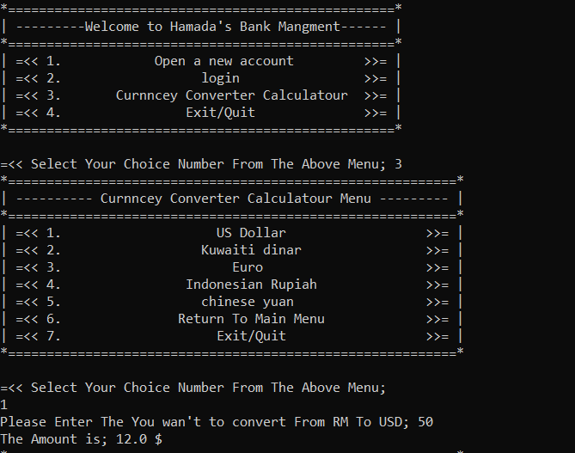**CURRNCY CONVERTER CALCULATOUR:**

**LOGIN:**

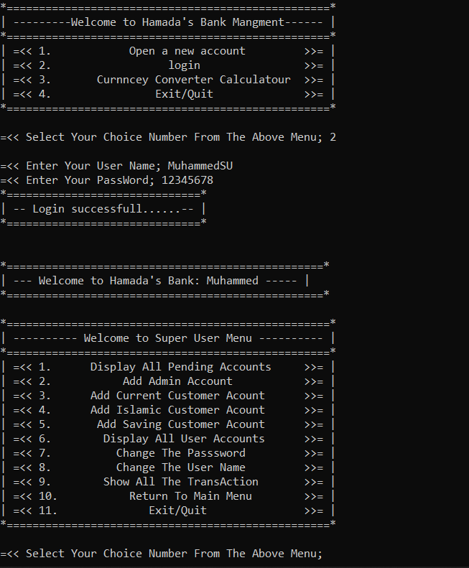

**ADD ADMIN:**

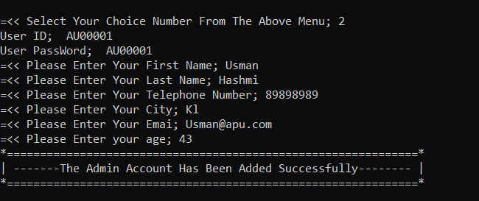

**ADMIN MENU:**

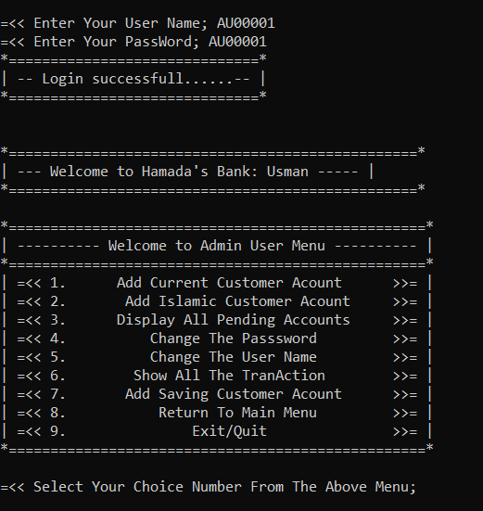

**ADD ISLAMIC CUSTOMER ACCOUNT:**

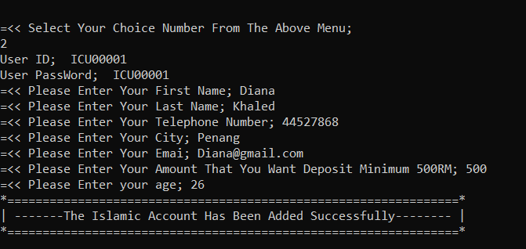

**ADD SAVING ACCOUNT:**

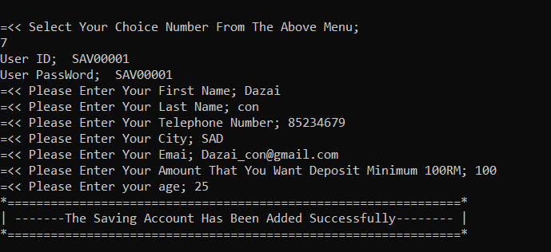

**ADD CURRENT CUSTOMER ACCOUNT:**

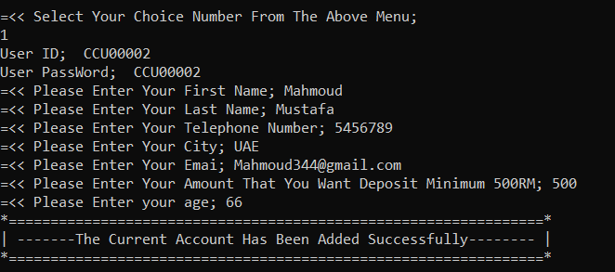

**DISPLAY ALL USERS:**

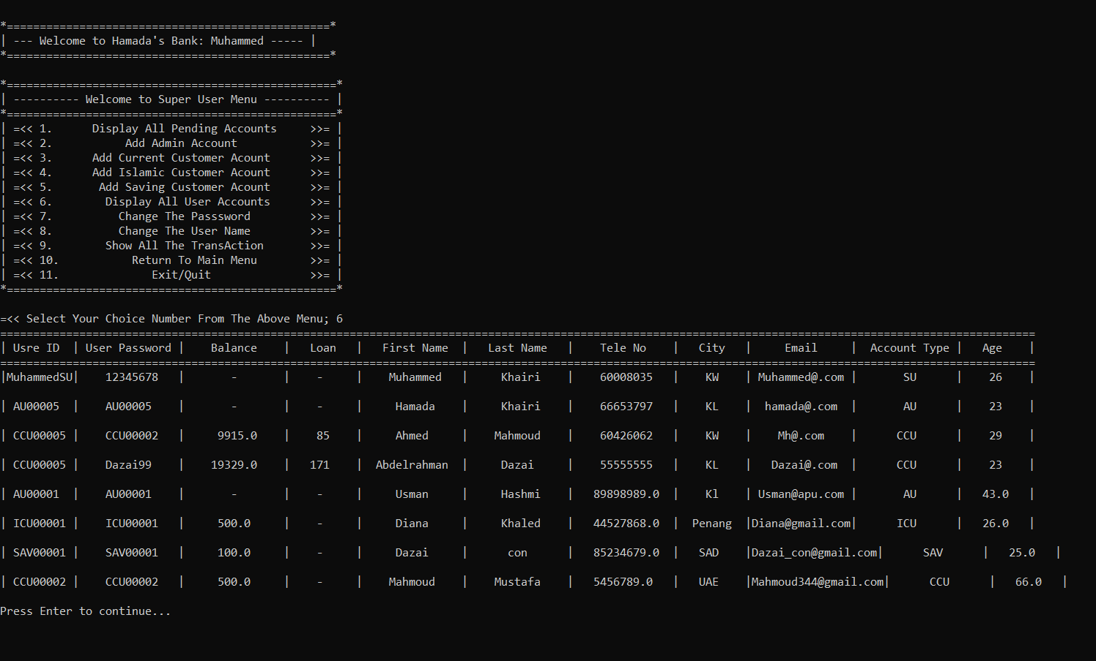

**DISPLAY ALL PENDING:**

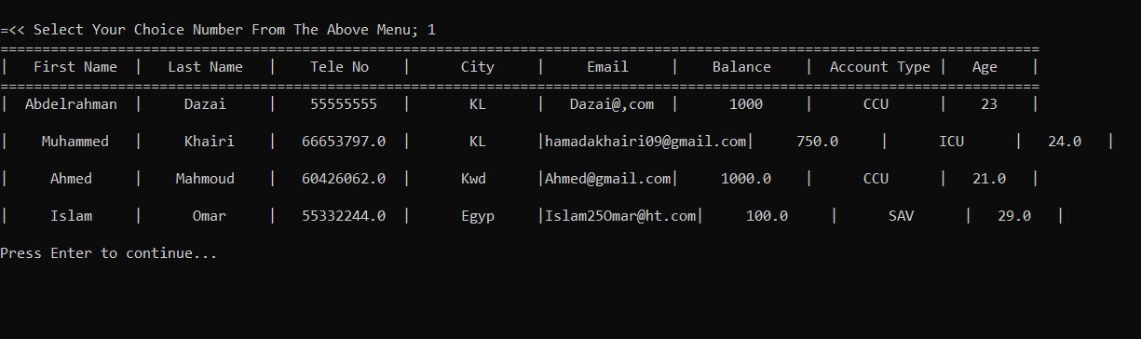

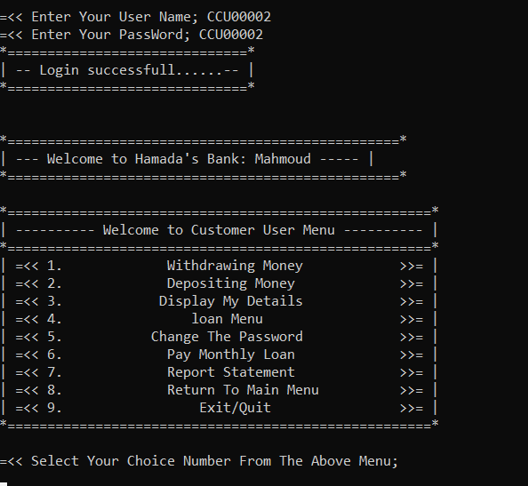**CUREENT CUSTOMER MENU:**

**ISLAMIC CUSTOMER MENU:**

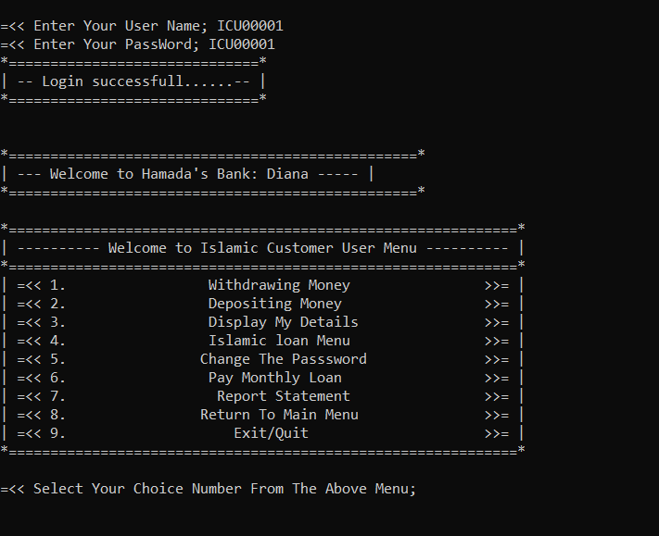

**DISPLAY DETAILS:**

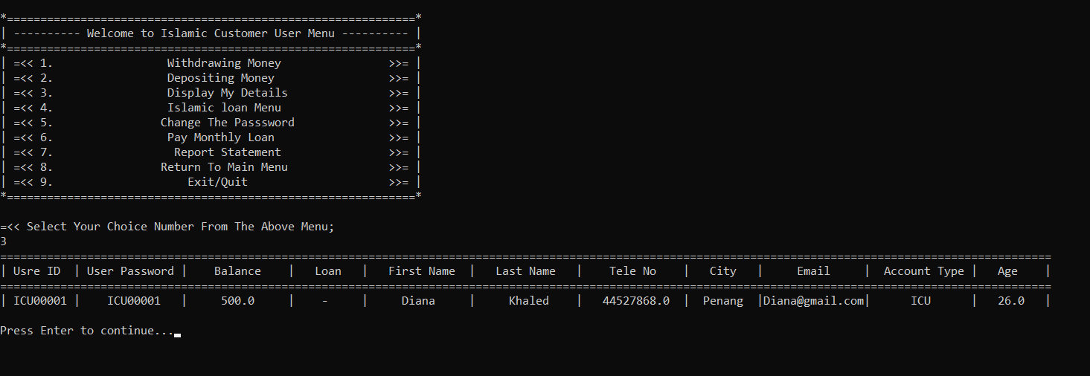

**SAVING ACCOUNT MENU:**

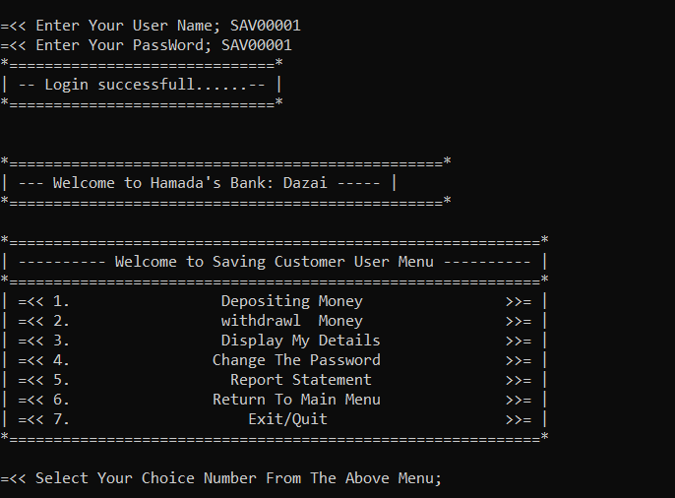

**WITHDRRAW:**

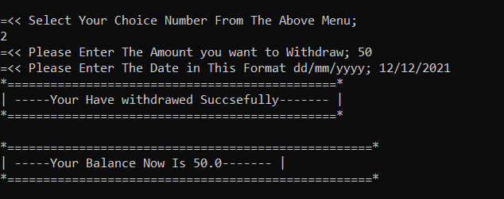

**DEPOSIT**:

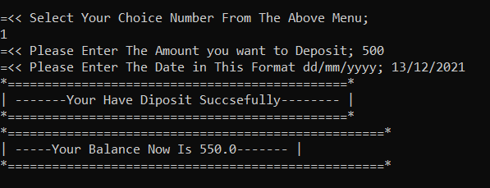

**CHANGE PASSWORD:**

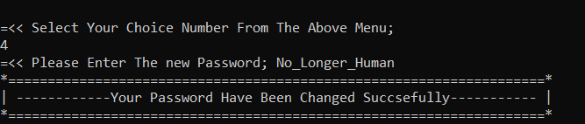

**Change Username:**

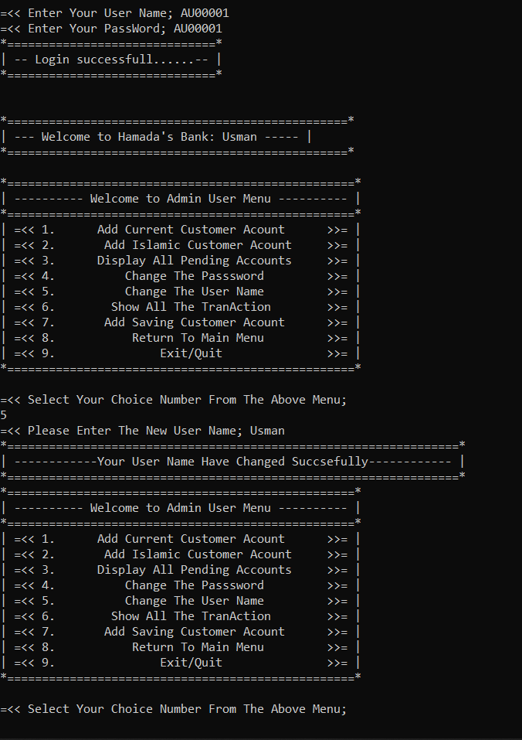

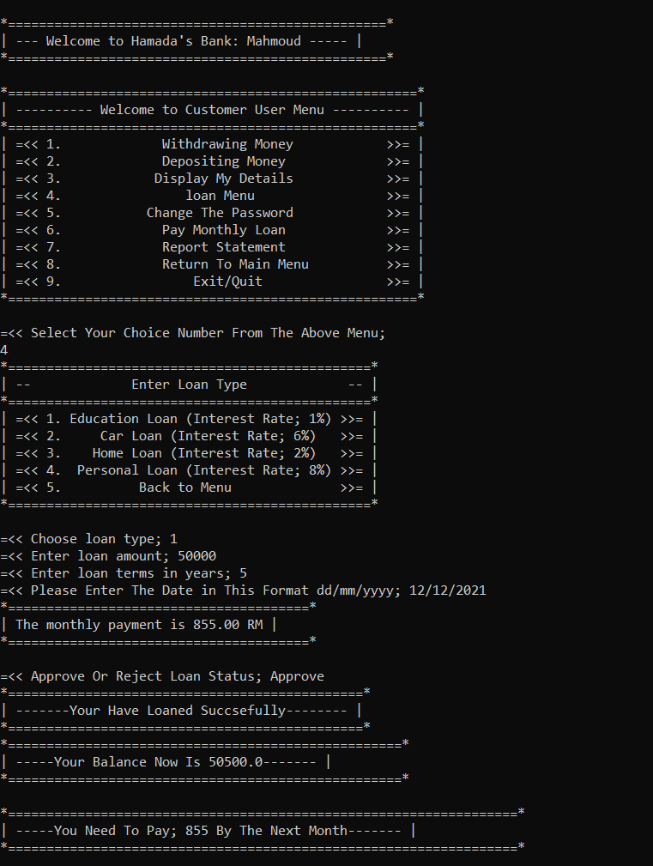**Current Loan:**

**Pay The Loan:**

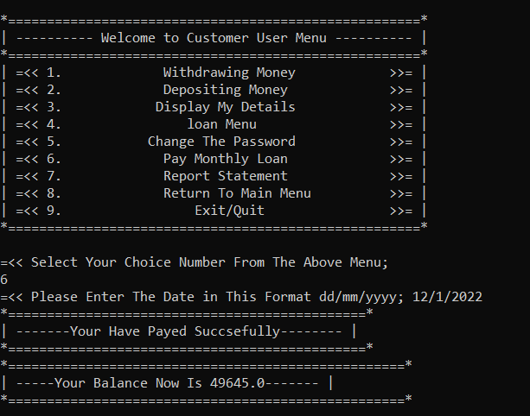

**Report:**

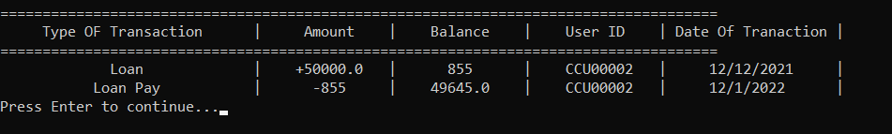

**Islamic Loan:**

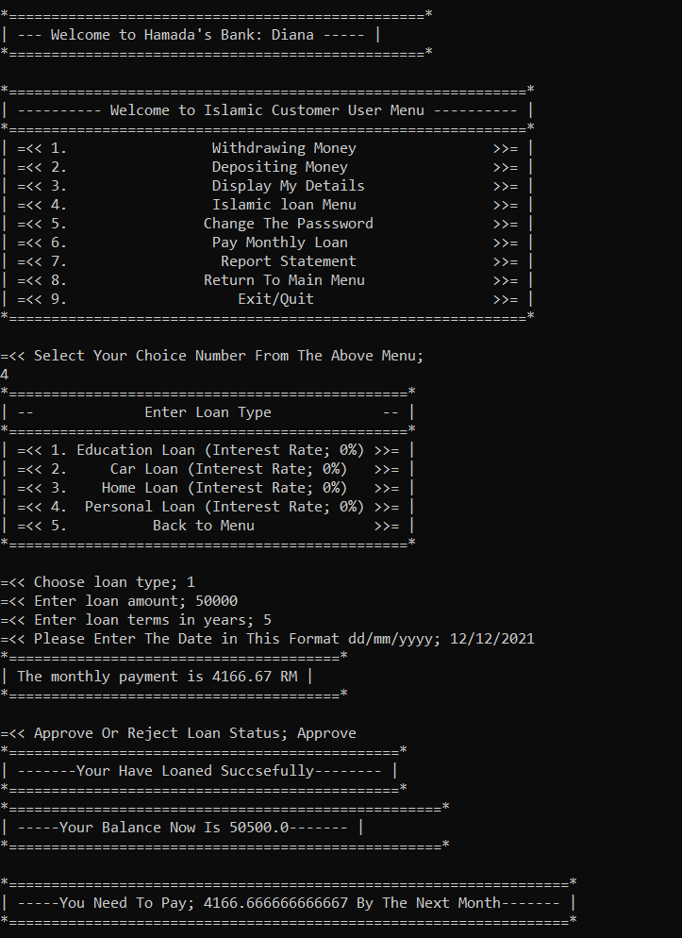

# Functions Table:

|  |  |  |
| --- | --- | --- |
| **Function Name** | **Screenshot** | **Explanation** |
| **GENERATE ID** |  | This code creates a special identifier for each customer or employee in the bank |
| **MAIN MENU** |  | This may be the first thing that the customer faces, as the customer decides whether he wants to open a new account or log in |
| **OPEN ACCOUNT MENU** |  | This function makes a request to open a new account |
| **ISLAMIC OPEN ACCOUNT** |  | function that open Islamic account |
| **CURRENT OPEN ACCOUNT** |  | Submit a work request for a user account, a regular account |
| **SAVING OPEN ACCOUNT** |  | Submit a work request for a user account, a Saving account |
| **LOGIN** |  | Login list for customers or employees |
| **SPUER USER MENU** |  | Superuser menu that allows him to control the bank system |
| **CUREENT CUSTOMER MENU** |  | The normal user menu where he has limited options |
| **SAVING ACCOUNT MENU** |  | The savings user list is not much different from the normal user list. |
| **ISLAMIC CUSTOMER MENU** |  | a function that displays Islamic customer menu |
| **ADMIN MENU** |  | The admin menu as it has great options, but it remains less than the options of the superuser |
| **ADD ISLAMIC CUSTOMER ACCOUNT** |  | a function that add Islamic customer account |
| **DISPLAY ALL PENDING** |  | This menu displays account opening requests. |
| **DISPLAY ALL USERS** |  | This list shows all the accounts registered within the bank |
| **ADD ADMIN** |  | From here, the superuser can add an admin |
| **ADD CURRENT CUSTOMER ACCOUNT** |  | a function that add current customer account |
| **ADD SAVING ACCOUNT** |  | a function that add a saving customer account |
| **WITHDRAW** |  | a function that makes the customer make withdraw transaction |
| **DEPOSIT** |  | a function that make the customer make a deposit transaction |
| **DISPLAY DETAILS** |  | a function that displays your details by opening the file and read it only your data |
| **CHANGE PASSWORD** |  | function that can make you change your password |
| **CHANGE USERNAME** |  | a function that change your username available only for admin and superuser |
| **CURRENT LOAN MENU** |  | a function that displays you the loan end menu |
| **ISLAMIC LOAN MENU** |  | a function that displays you the Islamic loan menu |
| **LOAN DEPOSIT** |  | a function that displays for you how much that you need to pay the next month and save your transaction details in the file |
| **LOAN DEPOSIT PAY** |  | a function that helped the loan deposit with saving the details |
| **PAY THE LOAN** |  | a function that make you pay your loan |
| **REPORT** |  | function that opened the transaction file and read it and display for the customer his transaction history |
| **SHOW ALL TRANS** |  | a function that shows all the transaction that made by the customers only the admin and the superuser can see it |

# Conclusion:

I learned the way to apply the abilities I learned in applied science categories to real-world things. "Trash in, trash out" became apparent to American state throughout this endeavor (Tech Target Contributor, 2008). It's attainable for code malfunctions to be caused by incorrect input. Professors and friends can perpetually teach American state the way to be a lot of easy and economical. I will be able to perpetually try for this. This course of study can hopefully improve my ability to jot down code. Take a course on system visualization in many programming languages. As a result, I will be ready to come back up with artistic ideas that profit the full community. Victimisation the incorrect knowledge or change of state with the code may produce issues.

# References

1. Visual Studio Code (Version 1.63). (2016). [Visual Studio Code is a source-code editor made by Microsoft for Windows, Linux and macOS.]. Microsoft.

<https://code.visualstudio.com/>

1. HASHMI, U. S. M. A. N. [PYP]. (2021, November 28). Building a bank system in Python [Video]. Teams. <https://cloudmails.sharepoint.com/:v:/r/sites/CT108-3-1-PYP-L-6___2021-09-30/Shared%20Documents/General/Recordings/Lab%2027/CT108-3-1-PYP-LAB-27==APD1F2109CS(CYB),%20APU1F2109CS(CYB)-20211124_095926-Meeting%20Recording.mp4?csf=1&web=1&e=UBwWru>
2. Python Keywords. (n.d.). W3schools. Retrieved December 2021, from <https://www.w3schools.com/python/python_ref_keywords.asp>
3. Python. (2021, October 4). Python 3.10.1. Retrieved December 2021, from <https://www.python.org/downloads/>
4. Schafer, C. [Corey Schafer ]. (2017, May 1). Conditionals and Booleans - If, Else, and Elif Statements [Video]. YouTube. <https://youtu.be/DZwmZ8Usvnk>
5. Pseudo code keywords. (n.d.). Brainkart. Retrieved November 25, 2021, from <https://www.brainkart.com/article/Pseudo-code_35895/>
6. flowchart shape meaning. (n.d.). Flowchart Symbols. Retrieved November 28, 2021, from <https://www.smartdraw.com/flowchart/flowchart-symbols.htm>
7. Python. (n.d.). Geeksforgeeks. Retrieved December 5, 2021, from <https://www.geeksforgeeks.org/python-programming-language/?ref=shm>
8. Python. (2021a, September 4). W3schools. Retrieved November 28, 2021, from <https://www.w3schools.com/python/default.asp>
9. Uses of functions. (2021). Launchschool. Retrieved December 2021, from <https://launchschool.com/>
10. Dealing with functions. (2021, June 14). Datacamp. Retrieved December 11, 2021, from <https://www.datacamp.com/>
11. Codezilla. (2020, April 18). Python course [Video]. YouTube. <https://www.youtube.com/watch?v=h3VCQjyaLws&list=PLuXY3ddo_8nzrO74UeZQVZOb5-wIS6krJ&ab_channel=Codezilla>